MVC NOTES
www.enosislearning.com

Overview of MVC 5
MVC Architecture 6
Components of MVC(Model-View-Controller) 6
Model 6
View 6
Controller 6
Flow of MVC [ login.aspx - > logic -> database] 7
Advantages of MVC 7
Advantages of ASP.NET MVC Framework 8
Disadvantages of MVC 8
History of M.V.C 9
Versions of MVC 10
ASP.NET MVC 3 Features: 10
ASP.NET MVC 4 Features: 10
ASP.NET MVC 5 Features 11
ASP.NET MVC 6 Features 12
MVC File Structure & File Naming Standards 12
Creating a MVC Project 13
HomeController.cs 15
// index.cshtml 16
MVC Life Cycles 18
The Application Life Cycle 18
The Request Life Cycle 18
ASP.NET MVC Execution Life Cycle 19
Asp.net MVC Request Life Cycle 21
1. Routing 21
2. MvcHandler 22
3. Controller 22
4. View Result 22
5. View Engine 22
6. View 22
Flow of MVC Application 23
View Engine 24
Razor 24
ASPX 25
Controller Actions 26
Controller 26
Request Processing 26
Action Types In MVC 29
Action Results 29
Examples of Return Types 32
Action Result of MVC 34
Adding an Action method 38
MusicStoreController.cs 38
Controllers and Action Methods in ASP.NET MVC Applications 39
ActionVerbs 40
UNDERSTANDING MVC CONTROLLER 43
GET and POST Request Type 43
Calculate Simple Interest 43
Get the view's data in the Action Method 44
1. Using Traditional Approach 45
2. Using the FormCollection Object 45
3. Using the Parameters 46
4. Strongly type model binding to view 47
1 Controller-to-View 48
1.1 ViewData 48
ViewData 49
1.2 ViewBag: 49
ViewBag 49
1.3 TempData: 51
TempData 51
ViewData, ViewBag and TempData Current Request Example 52
2 Controller-to-Controller 53
Other Approaches in MVC 54
ViewModel 54
Partial View 55
Tuple 55
Standard HTML Helpers 56
Rendering Links 56
Rendering Image Links : Url.Action() 57
TextBox() 57
TextArea() 58
Password 59
HiddenField 59
CheckBox 59
RadioButton() 59
DropDownList() 60
BeginForm() 60
EndForm() 61
Example: Using Controls in MVC View Pages. 61
Validation Rules 63
Model Validations in MVC with Data Annotations 63
Adding Validation Rules to the Model 63
MVC CLIENT SIDE VALIDATIONS 65
MVC SERVER SIDE VALIDATIONS 65
Approach 1: Manually Add Error to ModelState Object 65
Approach 2: Specifying Business Rules with Data Annotation 68
Data Annotations using MetaData class 70
Custom HTML Helpers 72
Creating a static method 72
Writing an extension method 72
Using the @helper(razor only) 73
.NET MVC - Security 74
Authentication 74
Authentication Options 76
No Authentication 76
Individual User Accounts 77
Work and School Accounts 78
Windows Authentication 78
Authorization 88
Layouts 94
Create an MVC Application 94
Create Layout for Application 95
The _ViewStart File 98
Partial View 98
View Vs Partial View 100
Areas : 100
Adding a New Area 101
Registering Areas with MVC Framework 102
Linking Between Two Areas 104
Redirecting to an Action Belonging to Another Area 104
Routing in MVC 105
How to define route... 105
How to define route... 109
Minification 109
Unobtrusive Validations 109
"Unobtrusive Validation" Mean? 109
MVC Filters 110
Types of Filters 110
Examples of ASP.NET MVC Filters 111
Authentication Filters 111
Authorization Filters 111
Action Filters 112
Result Filters 113
Exception Filters 113

Overview of MVC
“M” “V” “C” stands for “MODEL” “VIEW” “CONTROLLER”.
MVC design pattern aims to separate content from presentation and data-processing from content.
ASP.NET MVC is architecture to develop ASP.NET web applications in a different manner than the traditional ASP.NET web development.
Developing ASP.NET MVC application requires Microsoft .NET Framework 3.5 or higher.

MVC Interaction with Browser
Like a normal web server interaction, MVC application also accepts requests and responds to the web browser in the same way.
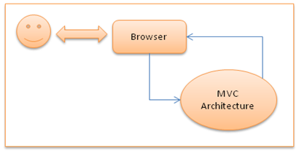

MVC Architecture
The entire ASP.NET MVC architecture Microsoft .NET Framework which consists of model, view and controller.

Components of MVC(Model-View-Controller)

Model
- MVC model is basically a C# or VB.NET class
- A model is accessible by both controller and view
- A model can be used to pass data from Controller to view
- A Model can also be used to get data from View to the Controller.
- A view can use model to display data in page.

View
- View is an ASPX page without having a code behind file
- All page specific HTML generation and formatting can be done inside view
- One can use Inline code (server tags ) to develop dynamic pages
- A request to view (ASPX page) can be made only from a controller’s action method
Public class MyController:Controller
{
Public ActionResult Home()
{
//Return content(“Hello welcome to my app”);
Return View(“Home”);
}
}

Controller
- Controller is basically a C# or VB.NET class which inherits system.mvc.controller
- Controller is a heart of the entire MVC architecture
- Inside Controller’s class action methods can be implemented which are responsible for responding to browser OR calling views.
- Controller can access and use model class to pass data to views
- Controller uses ViewData to pass any data to view

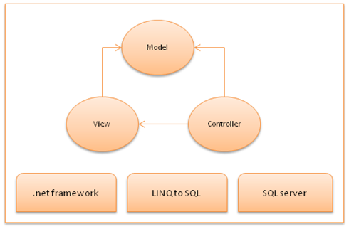

Flow of MVC [ login.aspx - > logic -> database]

Step 1: Incoming request directed to Controller.
Step 2: Controller processes request and forms a data Model.

Step 3: Model is passed to View.
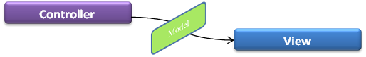
Step 4: View transforms Model into appropriate output format.
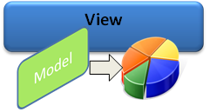
Step 5: Response is rendered.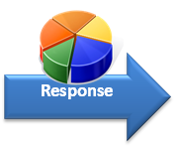

Advantages of MVC
- Separation of concerns –
One of the advantages of using ASP.NET MVC is it enforces separation of concerns. So there is very less chances of getting things more complex.
- Test Driven development and Reusability –
- In MVC controller is a separate class so automatic testing is possible featuring Test Driven Development.  - Controllers are not bound to any specific view and so can be reused for multiple views. | 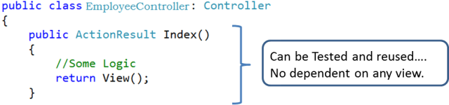
- Performance - ASP.NET MVC don’t have support for view state, so there will not be any automatic state management which reduces the page size and so gain the performance.
- Full control over HTML - ASP.NET MVC doesn’t support server controls, only option available is using html input controls, so we will be sure about final html rendered at the end.
And so integration of ASP.NET MVC application with third party JavaScript libraries like jQuery becomes easy.
- Support for parallel development - In ASP.NET MVC layers are loosely coupled with each other, so one developer can work on Controller, at the same time other on View and third developer on Model. This is called parallel development.
- SEO, URL routing and REST - Rich routing features lets treat every URL as a resource supporting RESTful interfaces.
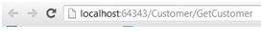Also user-friendly and readable URL improves SEO.
- Extensibility - ASP.NETMVC supports multiple view engines like aspx, razor and if required we can create our own.
- Existing ASP.NET Features – ASP.NET MVC framework is built on top of matured ASP.NET framework and thus provides developer to use many good features such as forms authentication, windows authentication, caching, session etc.

Advantages of ASP.NET MVC Framework
This approach provides the following advantages.
- It manages application complexity by dividing an application into the model, view and controller.
- It does not use view state or server-based forms. This makes the MVC framework ideal for developers who want full control over the behavior of an application.
- It provides better support for test-driven development.
- It is suitable for large scale developer team and web applications.
- It provides high degree of control to the developer over the application behavior.

Disadvantages of MVC
- More learning effort - Absence of event driven programming model and ViewState makes ASP.NET MVC a very difficult framework for developers with no or little experience in web application development.

History of M.V.C

ASP.NET MVC 1.0 | The first official release, dated MIX 2009, brought all the core features of the framework, which made their way through the years till today:  - Obviously, the MVC concept, with the streamlined processing pipeline and the separation of the processing of the request (in the Controller) and the rendering of the output (in the View)  - The concept of routing  - Lightweight helpers for rendering HTML tags  - Ajax helpers to easily ajaxify links and forms  - Automatic binding of posted forms to .NET objects and a kind of model validation
ASP.NET MVC 2 | The following year, same timeframe (MIX 2010), the second version of the framework came out.  - Model validation based on attributes, both server and client side  - Areas to partition bigger applications  - Html Templated helpers, to automatically render edit forms and display pages based on the model and attributes applied on it  - Asynchronous Controllers  - Lambda based Html Helpers to remove most of the "magic strings" previously needed in html helpers  The inclusion of the model validation and display attributes was also a first step toward some kind of support for a default model inside ASP.NET MVC.

Versions of MVC

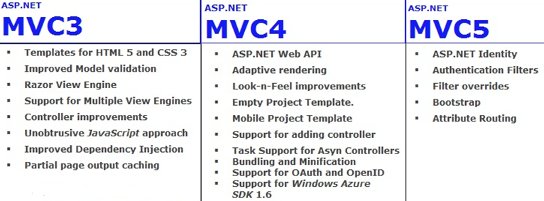

ASP.NET MVC 3 Features:
1. MVC 3 introduced a popular new feature that is called Razor.

2. MVC 3 introduced a new feature that is called bundling.

3. MVC 3 Start supporting to multiple views (Razor) engines.

4. MVC 3 introduced a popular new feature that is called ViewBag dynamic property.

5. MVC 3 introduced a popular new feature that is called ActionResults Types.

6. In MVC 3, added separates the functionality approach over the JavaScript in the presentation layer that is called to UX.

7. MVC 3 starts supporting to the HTML 5 and CSS 3.

8. MVC 3 added enhancement to validate a model.

9. MVC 3 improved the Dependency Injection by using the IDependencyResolver interface.

10. MVC 3 added output caching for Partial views.

ASP.NET MVC 4 Features:

- MVC 4 introduced a popular new feature that is called webapi framework and its work over the HTTP services.

- MVC 4 added and improves to default project templates.

- MVC 4 introduced to empty project template.

- MVC 4 introduced to new mobile project template.

- MVC 4 is going to support and adding controller to other project folders.

- MVC 4 is going to support the Asynchronous Controllers.

- MVC 4 introduced to bundling and Magnification concepts.

- MVC 4 introduced to OAuth and OpenID login with the help of DotNetOpenAuth library.

- MVC 4 going to support to Windows Azure SDK 1.6.

ASP.NET MVC 5 Features
- MVC 5 introduced to ASP.NET Identity for authentication and identity management.

- ASP.NET Identity is a new Membership provider to handle the authentication and authorization for social networking site just like Google, twitter, face-book etc.

- MVC 5 added to authentication filters for authenticate to users using third party authentication provider or your custom logic by using filter override methods and now we can override to filters on method and controller both.
- MVC 5 replaced to bootstrap by using the default template.

- MVC 5 added new to Attribute Routing [Route("Empolyee/{EmpID}")].

Example code look like.
[RoutePrefix("API/Company")]
public class CompanyController : BaseAPIController
{
[Route("Employee/{EmpId}")]
public ActionResult GetEmployeeById(string EmpId)
{
//TODO: Put your logic here.
return View();
}
}
The Attribute Routing work with both ActionResult and Controller Level.

Now, In MVC 5
- Empty Template
- Internate Application Template
- Intranet Application Template
- ASP.NET Web API Template
- Mobile Project Template
- Single Page Application Template
- Asp.Net Identity
- Bootstrap in the MVC 5 templates
- Authentication Filters
- Filter overrides

ASP.NET MVC 6 Features

- MVC 6 added new cloud computing optimization system of MVC , web API, SignalR and entity framework.

- The Microsoft make a bundle of MVC, Web API, WebPages, SignalR , That bundle we called MVC 6.

- In MVC 6, Microsoft removed the dependency of system.web.dll from MVC 6 because it's so expensive. Typically it consume 30K memory per request/response.

- Right now, in MVC 6 consume 2K memory per request response. It's too small memory consume.

MVC File Structure & File Naming Standards

MVC uses a standard directory structure and file naming standards which are a very important part of MVC application development.
Inside the ROOT directory of the application, there must be 3 directories each for model, view and Controller.
Apart from 3 directories, there must have a Global.asax file in root folder, and a web.config like a traditional ASP.NET application.
- Root [directory]
    - Controller [directory]
      - Controller CS files
    - Models [directory]
      - Model CS files
    - Views [directory]
      - View aspx/ascx files
  - Global.asax
  - Web.config

Creating a MVC Project

These following steps explain how to create MVC based web application.
- Create a Web Project
Click on file menu from the menu bar and select new submenu to create a new project. The following image show that how to create a new project.
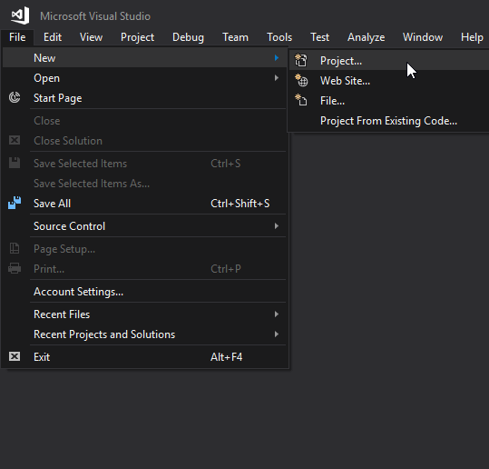
- Select Project Type
Here, select type of project as a web project and provide name of the project.
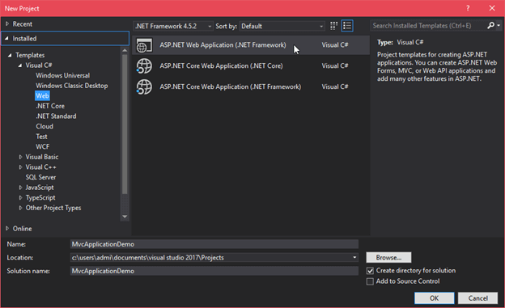
- Select MVC template
After selecting project type, now select the web template that we want to implement. Since we are working on MVC then select MVC template from the list of available template. At the same time, provide the authentication type to the application.
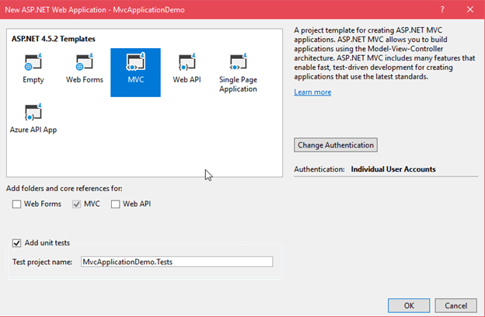
After clicking ok, it creates a project that has following structure:
- MVC Web Application Project Structure
Following is the project structure that we just created.
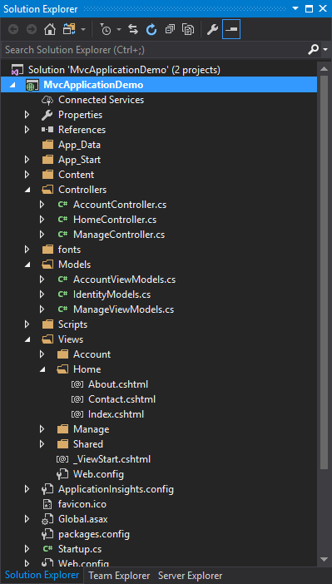
See, the project carefully, it contains three folders named Model, View and Controller. The HomeController is default controller for the application. This controller contains the following code:

HomeController.cs
using System;
using System.Collections.Generic;
using System.Linq;
using System.Web;
using System.Web.Mvc;
namespace MvcApplicationDemo.Controllers
{
public class HomeController : Controller
{
public ActionResult Index()
{
return View();
}
public ActionResult About()
{
ViewBag.Message = "Your application description page.";
return View();
}
public ActionResult Contact()
{
ViewBag.Message = "Your contact page.";
return View();
}
}
}

Index file is default for the home controller in the view folder.

// index.cshtml
- @{
- ViewBag.Title = "Home Page";
- }
- <div class="jumbotron">
- <h1>ASP.NET</h1>
- <p class="lead">ASP.NET is a free web framework for building great Web sites and Web applications
- using HTML, CSS and JavaScript.</p>
- <p><a href="https://asp.net" class="btn btn-primary btn-lg">Learn more</a></p>
- </div>
- <div class="row">
- <div class="col-md-4">
- <h2>Getting started</h2>
- <p>
- ASP.NET MVC gives you a powerful, patterns-based way to build dynamic websites that
- enables a clean separation of concerns and gives you full control over markup
- for enjoyable, agile development.
- </p>
- <p><a class="btn btn-default" href="https://go.microsoft.com/fwlink/?LinkId=301865">
- Learn more</a></p>
- </div>
- <div class="col-md-4">
- <h2>Get more libraries</h2>
- <p>NuGet is a free Visual Studio extension that makes it easy to add, remove, and update libraries
- and tools in Visual Studio projects.</p>
- <p><a class="btn btn-default" href="https://go.microsoft.com/fwlink/?LinkId=301866">
- Learn more</a></p>
- </div>
- <div class="col-md-4">
- <h2>Web Hosting</h2>
- <p>You can easily find a web hosting company that offers the right mix of features and price
- for your applications.</p>
<p><a class="btn btn-default" href="https://go.microsoft.com/fwlink/?LinkId=301867">
- Learn more</a></p>
</div>
</div>

MVC Life Cycles

MVC has two life cycles −
- The application life cycle
- The request life cycle
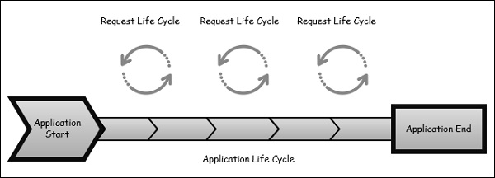

The Application Life Cycle
The application life cycle refers to the time at which the application process actually begins running IIS until the time it stops. This is marked by the application start and end events in the startup file of your application.

The Request Life Cycle
It is the sequence of events that happen every time an HTTP request is handled by our application.
The entry point for every MVC application begins with routing. After the ASP.NET platform has received a request, it figures out how it should be handled through the URL Routing Module.
Modules are .NET components that can hook into the application life cycle and add functionality. The routing module is responsible for matching the incoming URL to routes that we define in our application.
All routes have an associated route handler with them and this is the entry point to the MVC framework.
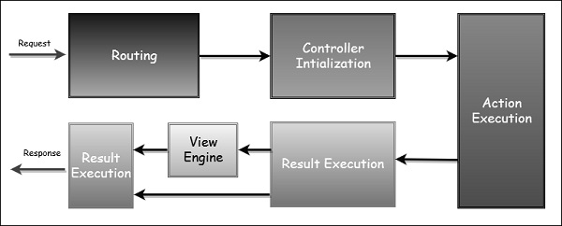
The MVC framework handles converting the route data into a concrete controller that can handle requests. After the controller has been created, the next major step is Action Execution. A component called the action invoker finds and selects an appropriate Action method to invoke the controller.
After our action result has been prepared, the next stage triggers, which is Result Execution. MVC separates declaring the result from executing the result. If the result is a view type, the View Engine will be called and it's responsible for finding and rending our view.
If the result is not a view, the action result will execute on its own. This Result Execution is what generates an actual response to the original HTTP request.

ASP.NET MVC Execution Life Cycle

Here is how MVC architecture executes the requests to browser and objects interactions with each other.
A step by step process is explained below [Refer to the figure as given below]:
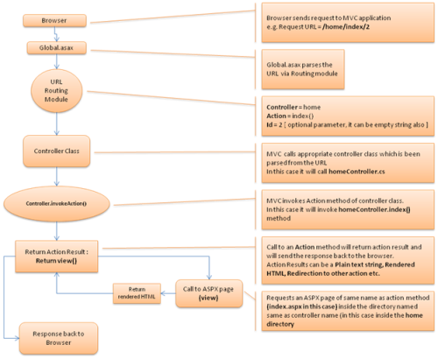
STEP1: Browser Request : Browser request happens with a specific URL. Let’s assume that the user enters URL like: [xyz.com]/home/index/

STEP 2:Job of Global.asax – MVC routing : The specified URL will first get parsed via application_start() method inside Global.asax file. From the requested URL, it will parse the Controller, Action and ID.
So for [xyz.com]/home/index/:
Controller = home
Action = index()
ID = empty — we have not specified ID in [xyz.com]/home/index/, so it will consider as empty string
STEP 3: Controller and Action methods

MVC now finds the home controller class in controller directory. A controller class contains different action methods,There can be more than one action method, but MVC will only invoke the action method which has been parsed from the URL, its index() in our case.
So something like: homeController.index() will happen inside MVC controller class.
Invoking action method can return plain text string OR rendered HTML by using view.
STEP 4: Call to View

Invoking view will return view(). A call to view will access the particular ASPX page inside the view directory and generate the rendered HTML from the ASPX and will respond back to the browser.In our case, controller was home and action was index(). So calling view() will return a rendered HTML from the ASPX page located at /views/home/index.aspx.

Asp.net MVC Request Life Cycle

While programming with Asp.net MVC, you should be aware of the life of an Asp.net MVC request from birth to death. In this article, I am going to expose the Asp.net MVC Request Lifecycle. There are six main steps that happen when you make a request to an Asp.net MVC web applications:

Routing
Asp.net Routing is the first step in MVC request cycle which matches the request’s URL against the registered URL patterns in the Route Table. When a matching pattern found in the Route Table, the Routing engine forwards the request to the appropriate handler for that request. Otherwise, the routing engine returns a 404 HTTP status code against that request.
When application starts at first time, it registers one or more patterns to the Route Table to tell the routing system what to do with any requests that match these patterns. An application has only one Route Table and this is setup in the Global.asax file of the application.
  - Public static voidRegisterRoutes(RouteCollection routes)
  - {
  - routes.IgnoreRoute("{resource}.axd/{*pathInfo}");
  - routes.MapRoute("Default",// Route name
  - "{controller}/{action}/{id}",// URL with parameters
  - new{ controller ="Home", action ="Index", id =UrlParameter.Optional}// Parameter defaults
  - );
  - }

MvcHandler
The handler returned from the RouteTable will always be an MvcHandler and represents a particular RouteContext. Actually, MvcHandler creates a controller, and also executes the controller.
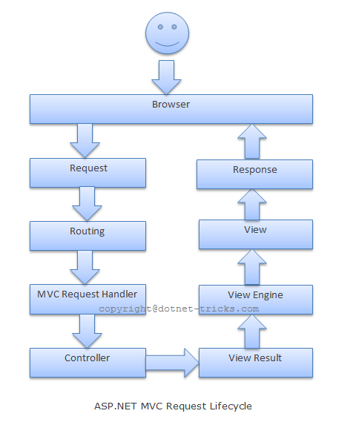

Controller
The controller determines which action method of the controller class to call, and then calls that method

View Result
The action method receives user input, prepares the appropriate response data, and then executes the result by returning a result type. The result type can be ViewResult, RedirectToRouteResult, RedirectResult, ContentResult, JsonResult, FileResult, and EmptyResult.

View Engine
Now the ViewResult calls into the current view engine to render the view. Controller is responsible only for preparing the data and decides which view to display by returning a ViewResult instance.

View
The data rendered by the current view engine is displayed on the view.

Note: - There is nothing as such called as MVC life cycle. I think lot of people are obsessed with ASP.NET page life cycle and they think there is life cycle in MVC as well. To be specific the MVC request goes through various steps of execution and that's what is termed as MVC application life cycle.

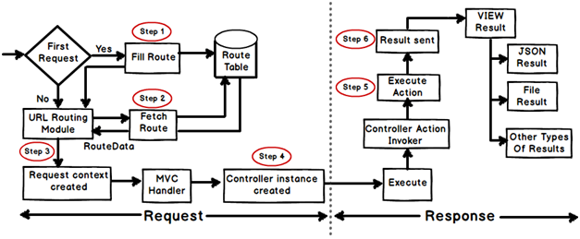

Flow of MVC Application

Any web application has two main execution steps first understanding the request and depending on the type of the request sending out appropriate response. MVC application life cycle is not different it has two main phases first creating the request object and second sending our response to the browser.
Creating Response object: - The request object creation has four major steps. Below is the detail explanation of the same.
Step 1 Fill route: - MVC requests are mapped to route tables which in turn specify which controller and action to be invoked. So if the request is the first request the first thing is to fill the route table with routes collection. This filling of route table happens in the global.asax file.

Step 2 Fetch route:- Depending on the URL sent "UrlRoutingModule" searches the route table to create "RouteData" object which has the details of which controller and action to invoke.

Step 3 Request context created: - The "RouteData" object is used to create the "RequestContext" object.

Step 4 Controller instance created: - This request object is sent to "MvcHandler" instance to create the controller class instance. Once the controller class object is created it calls the "Execute" method of the controller class.

Creating Response object: - This phase has two steps executing the action and finally sending the response as a result to the view.

Step 5 Execute Action: - The "ControllerActionInvoker" determines which action to executed and executes the action.

Step 6 Result sent: - The action method executes and creates the type of result which can be a view result , file result , JSON result etc.

So in all there are six broad steps which get executed in MVC application life cycle.

View Engine
What is View Engine? Types of View Engine
View Engine is responsible for rendering the view into html form to the browser. By default, Asp.net MVC support Web Form (ASPX) and Razor View Engine. There are many third party view engines (like Spark, Nhaml etc.) that are also available for Asp.net MVC. Now, Asp.net MVC is open source and can work with other third party view engines like Spark, Nhaml.

Razor
The Razor view engine is an advanced view engine from Microsoft, packaged with MVC 3. Razor using an @ character instead of aspx's <% %> and Razor does not require you to explicitly close the code-block, this view engine is parsed intelligently by the run-time to determine what is a presentation element and what is a code element.

This is the default view engine in MVC . Web pages with Razor syntax have the special file extension cshtml (Razor with C#) or vbhtml (Razor with VB).

ASPX
The syntax for writing views with this engine is the same syntax that the ASP.NET Web Forms uses and the file extensions are also taken from ASP.NET Web Form (.aspx, .ascx, .master). The coding will give us the memory of legacy ASP style.
This is the default view engine for MVC 1 and MVC 2.
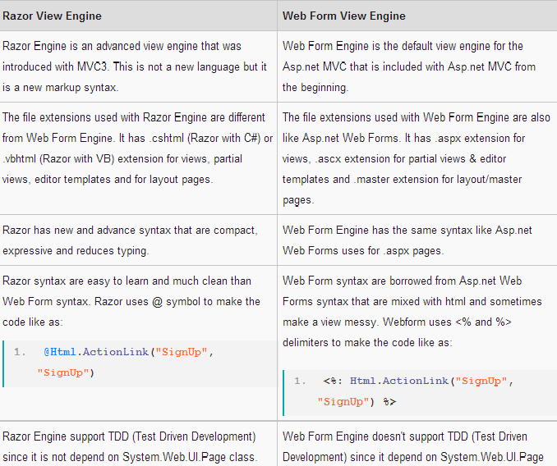
<h1>Sample with Razor</h1>  <h3>  Hello @name, the year is @DateTime.Now.Year  </h3>  <p>  checkout <ahref="/Products/Details/@produtid">this prodcut</a>  </p> | <h1>Sample with ASPX </h1>  <h3>  Hello <%=name %>, the year is <%= DateTime.Now.Year %>  </h3>  <p>  checkout <ahref="/Products/Details/<%=produtid %>">this prodcut</a>  </p>

Controller Actions

Asp.net MVC Controllers are responsible for controlling the flow of the application execution. When you make a request (means request a page) to MVC applications, a controller is responsible for returning the response to that request.
A controller can have one or more actions.
A controller action can return different types of action results to a particular request.
The Action Output is rendered into the Browser as output.The Action Output can be view,string, File,Javascript or Jscon Result.

Controller
Basically, the controller Receives input like as form values, query strings values etc. from users via the View and perform required operations on the user's inputs with the help of Model and passing the results back to the View. Actually, controllers are classes that have methods or action results and these actions results are called by the routing system to process a particular request.
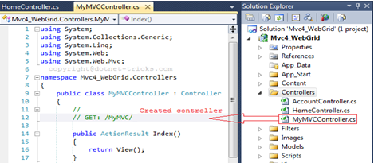
Controller actions are methods defined in the controller class and responsible to perform required operations on the user's inputs like as form values, query strings values etc. with the help of Model and passing the results back to the View.

Request Processing
Actions are the ultimate request destination in an MVC application and it uses the controller base class. Let's take a look at the request processing.
- When a URL arrives, like /Home/index, it is the UrlRoutingModule that inspects and understands that something configured within the routing table knows how to handle that URL.
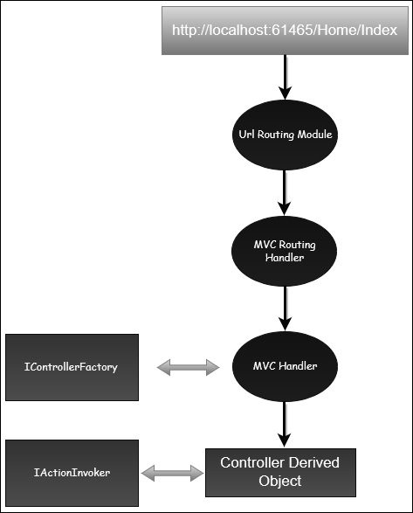
- The UrlRoutingModule puts together the information we've configured in the routing table and hands over control to the MVC route handler.
- The MVC route handler passes the controller over to the MvcHandler which is an HTTP handler.
- MvcHandler uses a controller factory to instantiate the controller and it knows what controller to instantiate because it looks in the RouteData for that controller value.
- Once the MvcHandler has a controller, the only thing that MvcHandler knows about is IController Interface, so it simply tells the controller to execute.
- When it tells the controller to execute, that's been derived from the MVC's controller base class. The Execute method creates an action invoker and tells that action invoker to go and find a method to invoke, find an action to invoke.
- The action invoker, again, looks in the RouteData and finds that action parameter that's been passed along from the routing engine.
Sr.No. | Name and Behavior
1 | ContentResult  Returns a string
2 | FileContentResult  Returns file content
3 | FilePathResult  Returns file content
4 | FileStreamResult  Returns file content
5 | EmptyResult  Returns nothing
6 | JavaScriptResult  Returns script for execution
7 | JsonResult  Returns JSON formatted data
8 | RedirectToResult  Redirects to the specified URL
9 | HttpUnauthorizedResult  Returns 403 HTTP Status code
10 | RedirectToRouteResult  Redirects to different action/different controller action
11 | ViewResult  Received as a response for view engine
12 | PartialViewResult  Received as a response for view engine

Action Types In MVC
Asp.net MVC has the following Built-in Action Results Type and Helper methods:
In MVC all actions are performed through controller. Controller assume each method as an action. Each action method has a return type and we call it as action result.
There are plenty of action results are available according to need but all action results are inherited by ActionResult class.
This is the base action result used in controller to perform any type of action. We can return any action type with ActionResult class. Let see action results with some example.
It is preferred to make a method private if it is not an action method.

Action Results
There is a list of action results type available to be used as return type of a method in controller and ActionResult class is the base class for all. It means this type can be used with any method as a result. First of all let us see different types of action results available and then we can discuss each one by one.
Action Result | Associated Method | Description
ViewResult | View() | Renders a view.
Used to renders a view.
public ActionResult Index()
{
//It will render index view.
return View();
}

You can also render view by passing view name in View() method like below. Below method will render Login view.
public ViewResult CallViewResult()
{
return View("Login");
}
PartialViewResult | PartialView() | Renders a partial view.
Below method takes int parameter and passing it as model. Also note that I am using HttpPost method type so this method cannot be directly called from browser.

[HttpPost]
public PartialViewResult CallPartial(int value)
{
return PartialView("_InnerPartial", value);
}
By default no method type is defined on action method and it can be access as get or post. But if you define method type as HttpPost, it means it is of post type and if you define it as HttpGet then it is of get type.
RedirectResult | Redirect(), RedirectPermanent() | Redirects to another action method using URL in method.
Used to redirects to another action method using URL in method. Below method will be redirected to given url.
public RedirectResult CallRedirectResult()
{
//Redirect to given url
return Redirect("/Example/Index");
}
You can also permanently redirect to a perticular url with RedirectPermanent() method.
public RedirectResult CallRedirectPermanentResult()
{
//url to redirect
return RedirectPermanent("/Example/Index");
}
RedirectToRouteResult | RedirectToAction(), RedirectToActionPermanent(), RedirectToRoute(), RedirectToRoutePermanent() | Redirects to action.
Used to redirects to another action. You can use RedirectToAction() method to perform this task or you can use RedirectToRoute() method. Let's first see RedirectToAction() method. We pass action name in this method and it will redirect to that method.
public RedirectToRouteResult CallRedirectToAction()
{
TempData["mess"] = "Redirected from CallRedirectToAction method...";
//I have defined a route 'MyTestRoute' for this action and when CallRedirectToAction() method will execute, it will replace url with that route url.
return RedirectToAction("CallViewResult");
}
Now let's see an example of RedirectToRoute() method. Here we pass route name what we have defined in route table.
public RedirectToRouteResult CallRedirectToRoute()
{
TempData["mess"] = "Redirected from RedirectToActionPermanent method...";
//put name of route and it will redirect to the url defined for that route.
//Below is the route defined in RouteConfig.cs
//routes.MapRoute(name: "RouteDefault",url: "MyTestRoute",
// defaults: new { controller = "Example", action = "CallViewResult"});
return RedirectToRoute("RouteDefault");
}
ContentResult | Content() | Returns content.
We can return content with this result type. In below example I have created a small HTML template and rendered it with the help of ContentResult.
public ContentResult CallContentResult()
{
System.Text.StringBuilder stringBuilder = new System.Text.StringBuilder();
stringBuilder.Append("<div style='width:100%;background-color:#ccc; float:left;padding-left:10px;'>");
stringBuilder.Append("<h1>This is header</h1>");
stringBuilder.Append("</div>");
return Content(stringBuilder.ToString());
}
FileResult | File() | Returns file or binary output.
You can render a file or binary output with this result. /// This will render image file
public FileResult CallFileResult()
{
string file=Server.MapPath("~/Files/fileupload.png");
return File(file, "image");
}
JsonResult | Json() | Returns Json.
Returns JSON result to client.
public JsonResult CallJsonResult()
{
return Json(new { Message = "This is JSON data", JsonRequestBehavior.AllowGet });
}
JavaScriptResult | JavaScript() | Returns JavaScript code to client.
Returns javascript result to ajax call.
public JavaScriptResult CallJavaScriptResult()
{
return JavaScript("alert('hello');");
}
HttpNotFoundResult | HttpNotFound() | Returns an error page showing File not found error message - 404.
Returns HTTP Not Found error page.
/// <summary>
/// Inherited from HttpStatusCodeResult class whose base class is again ActionResult class.
/// Means HttpNotFoundResult>HttpStatusCodeResult>ActionResult
/// </summary>
/// <returns></returns>
public HttpNotFoundResult CallHttpNotFoundResult()
{
//Will render error page- Not found with message you are passing
return HttpNotFound("I am testing error");
}
EmptyResult | None | Returns null or void.
Returns null result.
public EmptyResult CallEmptyResult()
{
//when nothing to return, can use this result.
return null;
}

Examples of Return Types

//View
public ViewResult Index()
{
return View("Login");
}
//Redirect to given url
public RedirectResult CallRedirectResult()
{
//Redirect to given url
return Redirect("/ActionReturn/Index");
// return Redirect("/ControllerName/ActionName");
}

public ActionResult CallRedirectAction()
{
//Redirect to given url
//return Redirect("/ActionReturn/Index");
return RedirectToAction("Index","ActionReturn");
//return RedirectToAction("ActionName", "ControllerName");
}

//It will return a string
public ContentResult CallContentResult()
{
StringBuilder stringBuilder = new StringBuilder();
stringBuilder.Append("<div style='width:100%;background-color:#ccc; float:left;padding-left:10px;'>");
stringBuilder.Append("<h1>This is header</h1>");
stringBuilder.Append("<h2>This is second header</h2>");
stringBuilder.Append("<h3>This is third header</h3>");
stringBuilder.Append("</div>");
return Content(stringBuilder.ToString());
}
Return a File

public FileResult CallFileResult()
{
string file = Server.MapPath("~/Files/fb.jpg");
return File(file, "image");

}

Return JSON Data
[HttpGet]
public JsonResult CallJsonResult()
{
var jsonResult = Json(new { Message = "This is JSON data", JsonRequestBehavior.AllowGet },JsonRequestBehavior.AllowGet);

jsonResult.MaxJsonLength = int.MaxValue;
return jsonResult;
}

Action Result of MVC

Action Result is a result of action methods or return types of action methods. Action result is an abstract class. It is a base class for all type of action results.
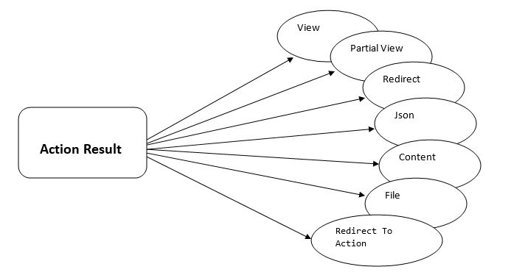
Figure 2: Types of Action Result
Redirect to Action Result
Redirect to Action result is returning the result to a specified controller and action method. Controller name is optional in Redirect to Action method. If not mentioned, Controller name redirects to a mentioned action method in current Controller. Suppose action name is not available but mentioned in the current controller, then it will show 404 page error.
- public ActionResult Index()
- {
- return RedirectToAction("Login", "Account");
- }
Json Result
Json result is a significant Action Result in MVC. It will return simple text file format and key value pairs. If we call action method, using Ajax, it should return Json result.
- public ActionResult Index()
- {
- var persons = new List<Person1>
- {
- new Person1{Id=1, FirstName="Harry", LastName="Potter"},
- new Person1{Id=2, FirstName="James", LastName="Raj"}
- };
- return Json(persons, JsonRequestBehavior.AllowGet);
- }
Output
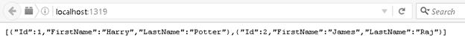
While returning more data in Json format, there is a need to mention maximum length. Assign maximum length of data Using “MaxJsonLength” property.
- public ActionResult Index()
- {
- var persons = new List<Person1>
- {
- new Person1{Id=1, FirstName="Harry", LastName="Potter"},
- new Person1{Id=2, FirstName="James", LastName="Raj"}

- };

- var jsonResult = Json(persons, JsonRequestBehavior.AllowGet);
- jsonResult.MaxJsonLength = int.MaxValue;
- return jsonResult;
- }
File Result
File Result returns different file format view page when we implement file download concept in MVC using file result. Simple examples for file result are shown below:
- public ActionResult Index()
- {
- return File("Web.Config", "text");
- }
Output
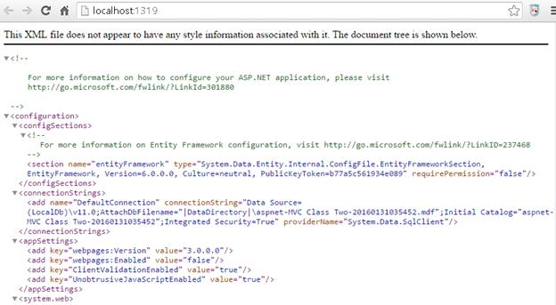
Content Result
Content result returns different content's format to view. MVC returns different format using content return like HTML format, Java Script format and any other format.
Example
- public ActionResult Contact()
- {
- ViewBag.Message = "Your contact page.";

- return View();
- }
Output
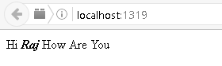
- public ActionResult Index()
- {
- return Content("<script>alert('Welcome To All');</script>");
- }
Output
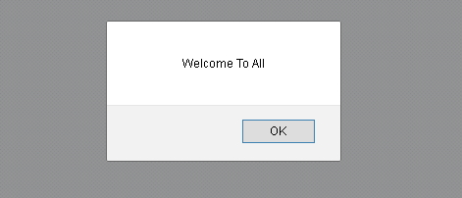

Action Result | Helper Method | Description
ViewResult | View | It is used to render a view as a Web page.
PartialViewResult | PartialView | It is used to render a partial view.
RedirectResult | Redirect | It is used to redirect to another action method by using its URL.
RedirectToRouteResult | RedirectToAction RedirectToRoute | It is used to redirect to another action method.
ContentResult | Content | It is used to return a user-defined content type.
JsonResult | Json | It is used to return a serialized JSON object.
JavaScriptResult | JavaScript | It is used to return a script that can be executed on the client.
FileResult | File | It is used to return binary output to write to the response.
EmptyResult | (None) | It represents a return value that is used if the action method must return a null result.

Adding an Action method
Here, we will add a new action method to the controller that we crested in previous chapter.
To add action to the existing controller, we need to define a public method to our controller. Our MusicStoreController.cs file is looks like the following after adding a welcome action method.

MusicStoreController.cs
using System;
using System.Collections.Generic;
using System.Linq;
using System.Web;
using System.Web.Mvc;
namespace MvcApplicationDemo.Controllers
{
public class MusicStoreController : Controller
{
// GET: MusicStrore
public ActionResult Index()
{
return View();
}
public string Welcome()
{
return "Hello, this is welcome action message";
}
}
}

Controllers and Action Methods in ASP.NET MVC Applications

The ASP.NET MVC framework maps URLs to classes that are referred to as controllers. Controllers process incoming requests, handle user input and interactions, and execute appropriate application logic. A controller class typically calls a separate view component to generate the HTML markup for the request.

The base class for all controllers is the ControllerBase class, which provides general MVC handling. The Controller class inherits from ControllerBase and is the default implement of a controller. The Controller class is responsible for the following processing stages:

- Locating the appropriate action method to call and validating that it can be called.
- Getting the values to use as the action method's arguments.
- Handling all errors that might occur during the execution of the action method.
- Providing the default WebFormViewEngine class for rendering ASP.NET page types (views).

All controller classes must be named by using the "Controller" suffix. The following example shows the sample controller class, which is namedHomeController. This controller class contains action methods that render view pages.

[HandleError]
Public class HomeController : Controller
{
public ActionResult Index()
{
ViewData["Message"] = "Welcome to ASP.NET MVC!";

return View();
}
public ActionResult About()
{
return View();
}
}

Marking Public Methods as Non-Action Methods

By default, the MVC framework treats all public methods of a controller class as action methods. If your controller class contains a public method and you do not want it to be an action method, you must mark that method with the NonActionAttribute attribute.
The following example shows a method that is marked with the NonAction attribute.
[NonAction]
Private void DoSomething()
{
// Method logic.
}

ActionVerbs
Another selector filter that you can apply is the ActionVerbs attributes. So this restricts the indication of a specific action to specific HttpVerbs. You can define two different action methods with the same name but one action method responds to an HTTP Get request and another action method responds to an HTTP Post request.
MVC framework supports the following ActionVerbs.
- HttpGet
- HttpPost
- HttpPut
- HttpDelete
- HttpOptions
- HttpPatch

Let’s take a look at a simple example in which we will create EmployeeController.
using System;
using System.Collections.Generic;
using System.Linq;

using System.Web;
using System.Web.Mvc;

namespace MVCControllerDemo.Controllers {
public class EmployeeController : Controller{
// GET: Employee
public ActionResult Search(string name = “No name Entered”){
var input = Server.HtmlEncode(name);
return Content(input);
}
}
}
Now let’s add another action method with the same name using the following code.
using System;
using System.Collections.Generic;
using System.Linq;

using System.Web;
using System.Web.Mvc;

namespace MVCControllerDemo.Controllers {
public class EmployeeController : Controller{
// GET: Employee
//public ActionResult Index()
//{
// return View();
//}

public ActionResult Search(string name){
var input = Server.HtmlEncode(name);
return Content(input);
}

public ActionResult Search(){
var input = "Another Search action";
return Content(input);
}
}
}
When you run this application, it will give an error because the MVC framework is unable to figure out which action method should be picked up for the request.
Let us specify the HttpGet ActionVerb with the action you want as response using the following code.
using System;
using System.Collections.Generic;
using System.Linq;

using System.Web;
using System.Web.Mvc;

namespace MVCControllerDemo.Controllers {
public class EmployeeController : Controller{
// GET: Employee
//public ActionResult Index()
//{
// return View();
//}

public ActionResult Search(string name){
var input = Server.HtmlEncode(name);
return Content(input);
}

[HttpGet]
public ActionResult Search(){
var input = "Another Search action";
return Content(input);
}
}
}
When you run this application, you will receive the following output.
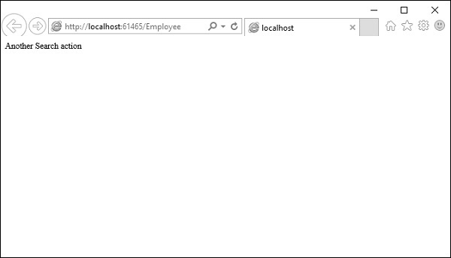

UNDERSTANDING MVC CONTROLLER
We use two types of methods to handle our browser request;
- HTTP GET
- HTTP POST
When we call an action method by a request's URL by the browser then the HTTP GET method will be called but when a request is from a button click event then the HTTP POST method will be called.
Explaining how to access view input field data in the controller's action method when a HTTP POST request is called.

GET and POST Request Type
To access view input field data in the controller's action method (POST), we create a "Calculate Simple Interest" application.
This application gets Principle, Rate and Time as user input and generates simple interest.
Create an action method in the CalculateSimpleInterest controller CalculateSimpleInterestController.cs) that renders the view on the UI.
public ActionResult SimpleInterest()
{
return View();
}
Create a view to get user input from the UI, so the code is:

Calculate Simple Interest
<fieldset>
<legend>Calculate Simple Interest</legend>
@using (Ajax.BeginForm("CalculateSimpleInterestResult","CalculateSimpleInterest",
new AjaxOptions { UpdateTargetId = "divInterestDeatils" }))
{
<div id="divInterestDeatils"></div>
<ol>
<li>
@Html.Label("Amount")
@Html.TextBox("txtAmount")
</li>
<li>
@Html.Label("Rate")
@Html.TextBox("txtRate")
</li>
<li>
@Html.Label("Year")
@Html.TextBox("txtYear")
</li>
</ol>
<button>Calculate</button>
}
</fieldset>

So now the screen is ready to get input and it shows it as:
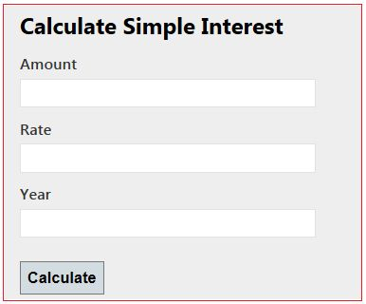
Figure 1.1 Input screens to calculate simple interest

Get the view's data in the Action Method
I will now explain the four ways to get the view's data in the controller action. These are:
- Using Traditional approach [Request]
- Using the FormCollection Object
- Using the Parameters
- Strongly type model binding to view

Using Traditional Approach
In the traditional approach we use the request object of the HttpRequestBase class. The request object has view input field values in name/value pairs. When we create a submit button then the request type POST is created and calls the POST method.
We have four data, those are in Name-Value pairs. So we can access these data in a POST method by passing the Name as an indexer in the Request and get values. Our POST method means the controller action that handles the POST request type is:
[HttpPost]
public ActionResult CalculateSimpleInterestResult()
{
decimal principle = Convert.ToDecimal(Request["txtAmount"].ToString());
decimal rate = Convert.ToDecimal(Request["txtRate"].ToString());
int time = Convert.ToInt32(Request["txtYear"].ToString());
decimal simpleInteresrt = (principle*time*rate)/100;
StringBuilder sbInterest = new StringBuilder();
sbInterest.Append("<b>Amount :</b> " + principle+"<br/>");
sbInterest.Append("<b>Rate :</b> " + rate + "<br/>");
sbInterest.Append("<b>Time(year) :</b> " + time + "<br/>");
sbInterest.Append("<b>Interest :</b> " + simpleInteresrt);
return Content(sbInterest.ToString());
}
When it executes, we get simple interest as the result as in the following:
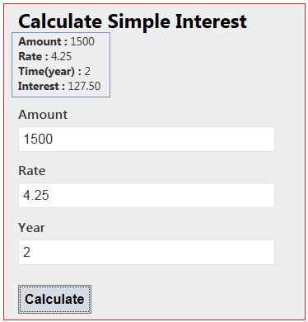

Using the FormCollection Object
We can also get post requested data by the FormCollection object. The FormCollection object also has requested data in the name/value collection as the Request object. To get data from the FormCollection object we need to pass it is as a parameter and it has all the input field data submitted on the form.
[HttpPost]
public ActionResult CalculateSimpleInterestResult(FormCollection form)
{
decimal principle = Convert.ToDecimal(form["txtAmount"].ToString());
decimal rate = Convert.ToDecimal(form["txtRate"].ToString());
int time = Convert.ToInt32(form["txtYear"].ToString());
decimal simpleInteresrt = (principle*time*rate)/100;
StringBuilder sbInterest = new StringBuilder();
sbInterest.Append("<b>Amount :</b> " + principle+"<br/>");
sbInterest.Append("<b>Rate :</b> " + rate + "<br/>");
sbInterest.Append("<b>Time(year) :</b> " + time + "<br/>");
sbInterest.Append("<b>Interest :</b> " + simpleInteresrt);
return Content(sbInterest.ToString());
}

It also gives the same output as shown above

Using the Parameters
We can pass all input field names as a parameter to the post action method. The input field name and parameter name should be the same. These parameters have input field values that were entered by the user. So we can access view input field values from these parameters. The input field takes a string value from the user so the parameter should be a string type. There is no need to define a parameter in any specific sequence.
[HttpPost]
public ActionResult CalculateSimpleInterestResult(string txtAmount, string txtRate, string txtYear)
{
decimal principle = Convert.ToDecimal(txtAmount);
decimal rate = Convert.ToDecimal(txtRate);
int time = Convert.ToInt32(txtYear);
decimal simpleInteresrt = (principle*time*rate)/100;
StringBuilder sbInterest = new StringBuilder();
sbInterest.Append("<b>Amount :</b> " + principle+"<br/>");
sbInterest.Append("<b>Rate :</b> " + rate + "<br/>");
sbInterest.Append("<b>Time(year) :</b> " + time + "<br/>");
sbInterest.Append("<b>Interest :</b> " + simpleInteresrt);
return Content(sbInterest.ToString());
}
It also gives the same output as Figure 1.3 shows.
In all three approaches above we are parsing the string to a non-string type. If any of the parsing attempts fail then the entire action will fail. We are converting each value to avoid an exception but it also increases the amount of code. So we look at the fourth approach that would reduce the amount of code.

Strongly type model binding to view
We bind a model to the view; that is called strongly type model binding.

Step 1: Create a Model for Simple Interest.
public class SimpleInterestModel
{
public decimal Amount { get; set; }
public decimal Rate { get; set; }
public int Year { get; set; }
}
Step 2: Create an action method that render a view on the UI.
We are passing an empty model to be bound to the view.
public ActionResult SimpleInterest()
{
SimpleInterestModel model = new SimpleInterestModel();
return View(model);
}
Step 3: Create a strongly typed view that has the same screen as in Figure 1.1.
@model CalculateSimpleInterest.Models.SimpleInterestModel
@{
ViewBag.Title = "SimpleInterest";
}
<h2>Calulate Simple Interest</h2>@using (Ajax.BeginForm("CalculateSimpleInterestResult","CalculateSimpleInterest",
new AjaxOptions { UpdateTargetId = "divInterestDeatils" }))
{
<fieldset>
<legend>Calulate Simple Interest</legend><div id="div1"></div>
<div class="editor-label">
@Html.LabelFor(model => model.Amount)
</div>
<div class="editor-field">
@Html.EditorFor(model => model.Amount)
</div>
<div class="editor-label">
@Html.LabelFor(model => model.Rate)
</div>
<div class="editor-field">
@Html.EditorFor(model => model.Rate)
</div>
<div class="editor-label">
@Html.LabelFor(model => model.Year)
</div>
<div class="editor-field">
@Html.EditorFor(model => model.Year)
</div>
<p>
<input type="submit" value="Calculate" />
</p>
</fieldset>
}
@section Scripts {
@Scripts.Render("~/bundles/jqueryval")
}
Step 4: Create an action method that handles the POST request and processes the data.
In the action method we pass a model as the parameter. That model has UI input field data. Here we do not need to parse and do not need to write extra code.
[HttpPost]
public ActionResult CalculateSimpleInterestResult(SimpleInterestModel model)
{
decimal simpleInteresrt = (model.Amount*model.Year*model.Rate)/100;
StringBuilder sbInterest = new StringBuilder();
sbInterest.Append("<b>Amount :</b> " + model.Amount+"<br/>");
sbInterest.Append("<b>Rate :</b> " + model.Rate + "<br/>");
sbInterest.Append("<b>Time(year) :</b> " + model.Year + "<br/>");
sbInterest.Append("<b>Interest :</b> " + simpleInteresrt);
return Content(sbInterest.ToString());
}

Controller-to-View
There are three options to pass information from controller to view. They are mentioned below:

ViewData
The ViewData is a Dictionary of objects that are derived from the 'ViewDataDictionary' class and its having keys as string type and a value for respective keys. It contains a null value on each redirection and it needs typecasting for complex data types.
For example: Assign value in controller action like:
ViewData["PersonName"] = "Test Name";
Fetch this ViewData value in View like this:
<h1><%= ViewData["PersonName"] %></h1>

ViewData
- ViewData is a dictionary object that is derived from ViewDataDictionary class.
- ViewData is used to pass data from controller to corresponding view.
- Its life lies only during the current request.
- If redirection occurs then its value becomes null.
- It’s required typecasting for complex data type and check for null values to avoid error.
Syntax : ViewData[“age”] = 35;
@ ViewData[“age”]

Advantages
- Using ViewData, we can send data from controller to view with inbuilt feature using keys.

Disadvantages
- It is meant for transferring data one-way only that is from controller to view.
- The value of ViewData persists only during current request. Its value cannot persist between requests so if redirection occurs, then its value becomes null.
- It is certainly a bad practice to overuse ViewData. It is not recommended in enterprise application, even though sometime it may use to show small data.
- Use key syntax, so not as readable as ViewBag which uses property style syntax.
- No intelligence support and compile-time error checking.

ViewBag:
ViewBag is just a dynamic wrapper around ViewData and exists only in ASP.NET MVC 3. ViewBag is a dynamic property that takes advantage of the new dynamic features in C# 4.0. It doesn't require typecasting for complex data types. It also contains a null value when redirection occurs.
For example: Assign value in controller action like:
ViewBag.PersonName= "Test Name";
Fetch this ViewData value in View like this:
<h1><%= ViewBag.PersonName %></h1>

ViewBag
- ViewBag is a dynamic property that takes advantage of the new dynamic features in C# 4.0.
- Basically it is a wrapper around the ViewData and also used to pass data from controller to corresponding view.
- Its life also lies only during the current request.
- If redirection occurs then its value becomes null.
- It doesn’t required typecasting for complex data type.
- ViewBag is a property of a Controller class that we generally used to share data between Controller and View and. ViewBag objects is wrapper around ViewData that is used to create dynamic properties for ViewBag.
ViewBag.Name = “value”;

Advantages
- Using ViewBag, we can send data from controller to view with minimal efforts.
- Syntax of ViewBag is better than ViewData. No need to use key.
- ViewBag doesn’t require type casting for data types.

Disadvantages
- It is meant for transferring data one-way only that is from controller to view.
- The value of ViewBag persists only during current request. Its value cannot persist between requests so if redirection occurs, then its value becomes null.
- It is certainly a bad practice to overuse ViewBag. It is not recommended in enterprise application, even though sometime it may use to transfer small data.
- No intelligence support and compile-time error checking.
- Technically speaking, it is slow as compared to ViewData but in real world scenarios, the difference is just negligible. (And at first place, micro optimization is bad.)

ViewBag Example
As we discussed earlier that ViewBag and ViewData serves the same purpose but ViewBag is basically a dynamic property (a new C# 4.0 feature) having advantage that it doesn’t have typecasting and null checks.
So, In order to pass data from Controller to View using ViewBag, we will modify our EmployeeController code as follows:
public class EmployeeController : Controller
{
// GET: /Employee/
public ActionResult Index()
{
ViewBag.EmployeeName = “Muhammad Hamza”;
ViewBag.Company = “Web Development Company”;
ViewBag.Address = “Dubai, United Arab Emirates”;
return View();
}
}
And to get Employee details passed from Controller using ViewBag, View code will be as follows:
<body>
<div>
<h1>Employee (ViewBag Data Example)</h1>
<div>
<b>Employee Name:</b> @ViewBag.EmployeeName<br />
<b>Company Name:</b> @ViewBag.Company<br />
<b>Address:</b> @ViewBag.Address<br />
</div>
</div>
</body>
In order to see the above changes in action run the solution, we will find the following output.
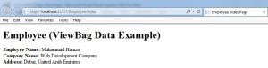

TempData:
TempData by default uses the session to store data, so it is nearly same to session only, but it gets cleared out at the end of the next request. It should only be used when the data needs only to persist between two requests. If the data needs to persist longer than that, we should either repopulate the TempData or use the Session directly.
For example:
In Controller : TempData["PersonName"] = "Test Name";
In View:
<h1><%= TempData["PersonName"] %></h1>

TempData
- TempData is a dictionary object that is derived from TempDataDictionary class and stored in short lives session.
- TempData is used to pass data from current request to subsequent request means incase of redirection.
- Its life is very short and lies only till the target view is fully loaded.
- It’s required typecasting for complex data type and check for null values to avoid error.
- It is used to store only one time messages like error messages, validation messages.

Advantages
- You can pass value from one action to another action or one controller to another controller.

Disadvantages
- It may introduce security risk as described above.
- It requires type casting for data type and check for null values to avoid error.
- No intellisense support in Visual Studio.

ViewData, ViewBag and TempData Current Request Example

CONTROLLER CODE
- public class HomeController : Controller
- {
- public ActionResult Index()
- {
- var emp = new Employee
- {
- EmpID=101,
- Name = "Deepak",
- Salary = 35000,
- Address = "Delhi"
- };
- ViewData["emp"] = emp;
- ViewBag.Employee = emp;
- TempData["emp"] = emp;
- return View(); }
- }
VIEW CODE

- @model MyProject.Models.EmpModel;
- @{
- Layout = "~/Views/Shared/_Layout.cshtml";
- ViewBag.Title = "Welcome to Home Page";
- var viewDataEmployee = ViewData["emp"] as Employee; //need typcasting
- var tempDataEmployeet = TempData["emp"] as Employee; //need typcasting
- }
- <h2>Welcome to Home Page</h2>
- <div>
- <a href="/Employees">
- <img src='@Url.Content("\\Content\\Images\\101.jpg")' alt="Best Employee "/>
- </a>
- <div>
- This Year Best Employee is!
//ViewBag Can be accessed directly without typecasting
- <h4>@ViewBag.emp.Name</h4>
- <h3>@viewDataEmployee.Name</h3>
- <h2>@tempDataEmployee.Name</h2>
</div>

Controller-to-Controller

If it's not private, just pass it as JSON object on the URL using the third parameter in the redirect as given in the below example:
return RedirectToAction("ActionName", "ControllerName", new { userId = id });
If it is private data, we can use TempData - which will be removed at the end of the request after the next request reads it.

The basic difference between ViewData and ViewBag is that in ViewData instead creating dynamic properties we use properties of Model to transport the Model data in View and in ViewBag we can create dynamic properties without using Model data.

Other Approaches in MVC
- ViewModel
- Partial View
- Tuple
An application can use more than one approach based on the requirement at a particular point.

ViewModel

ViewModel is a pattern that allow us to have multiple models as a single class. It aggregates models or contains their properties exactly as per the need of a view. ViewModel should not have methods. It should be a collection of properties needed for a view.

Typical Usages
It is the most widely used approach to pass multiple models to View in enterprise applications. It is the standard way you can use when you need to display multiple models in the view (applicable in case of partial view too).

Advantages
- ViewModel allows us to render multiple model types in a View as a single model.
- Great intellisense support and compile time error checking on View page.
- ViewModel is good for security purpose also as Views have only what they exactly need. Core domain models are not exposed to user.
- If there is any change in core domain model, you do not need to change anywhere in View code, just you need to modify corresponding ViewModel.
- In this way, ViewModel promotes loose coupling in application.

Disadvantages
- ViewModels add another layer between Models and Views so it increases the complexity a little bit. So for small and demo applications, we can use tuple or other ways to keep the things simple for demo.

Partial View
A Partial View is a sub-view that you can include in a parent view. In many cases, we have a situation where many Views have shared/common presentation, that common presentation is separated into a Partial View and used in other Views.

Typical Usages
This approach is also frequently used in enterprise applications along with ViewModels. It is used where you need to share the same code (Razor and HTML code) in more than one View.

Advantages
- It promotes reusability of code (Razor and HTML code) in application.
- It is very helpful for single page applications
- You can use ViewModel approach to Partial View too.
- Using Partial View, you can update a particular area of a View without refreshing the whole page using AJAX.

Disadvantages
- If used excessively, then View becomes a just aggregation of Partial Views, so sometime readability is compromised.

Tuple
Tuple is a new class introduced in .NET Framework 4.0. It is an ordered sequence, immutable, fixed-size collection of heterogeneous (allows us to group multiple kind of data types) objects.

Typical Usages
It may be good for small and demo applications. Tuple is a feature of C# language meant for specific scenarios , but if you are using it in ASP.NET MVC, you should use Tuple only when you do not want to create ViewModel.

Advantages
- It provides a way to aggregate models without creating new class (ViewModel)
- A quick remedy and need less coding efforts than ViewModel

Disadvantages
- Tuples is fixed size maximum limit of 8 items.
- Value is passes as item1, item2.....It is difficult to identify the arguments just by seeing the code.
- Not a great intellisense support in Visual Studio.

Standard HTML Helpers
The ASP.NET MVC framework includes a standard set of helpers that you can use to render the most common types of HTML elements. For example, you can use the standard set of helpers to render HTML links and HTML textboxes.
HTML Helper is just a method that returns a HTML string. The string can represent any type of content that you want. For example, you can use HTML Helpers to render standard HTML tags like HTML <input>, <button> and <img> tags etc.
You can also create your own HTML Helpers to render more complex content such as a menu strip or an HTML table for displaying database data.

Rendering Links
The easiest way to render an HTML link in a view is to use the HTML.ActionLink() helper.
The Html.ActionLink() does not link to a view.
Instead, you use the Html.ActionLink() helper to create a link to a controller action.
@Html.ActionLink("About this Website", "About" ) %>

In Listing 1, the first parameter passed to the Html.ActionLink() represents the link text and the second parameter represents the name of the controller action.

This Html.ActionLink() helper renders the following HTML:
<a href=”/Home/About”>About this Website</a>

The Html.ActionLink() helper has several overloads and supports several parameters:
· linkText – The label for the link.
· actionName – The action that is the target of the link.
· routeValues – The set of values passed to the action.
· controllerName – The controller that is the target of the link.
· htmlAttributes – The set of HTML attributes to add to the link.
· protocol – The protocol for the link (for example, https)
· hostname – The host name for the link (for example, www.MyWebsite.com)
· fragment – The fragment (anchor target) for the link
Notice that you can pass route values from an Html.ActionLink() to a controller action. For example, you might need to pass the Id of a database record that you want to edit. Here’s how you pass an Id parameter to the Edit() action:
@Html.ActionLink(“Edit Record”, “Edit”, new {Id=3})
When this Html.ActionLink() is rendered to the browser, the following link is created:
<a href=”/Home/Edit/3″>Edit Record</a>
*** Begin Note ***
Route values are URL encoded automatically. For example, the string “Hello World!” is encoded to “Hello%20World!”.
*** End Note ***

Rendering Image Links : Url.Action()

Unfortunately, you can’t use the Html.ActionLink() helper to render an image link.
Because the Html.ActionLink() helper HTML encodes its link text automatically, you cannot pass an <img> tag to this method and expect the tag to render as an image.
Instead, you need to use the Url.Action() helper to generate the proper link. Here’s how you can generate a delete link with an image:
Syntax:
<a href=”<%= Url.Action(“Delete”) %>”><img src=”../../Content/Delete.png” alt=”Delete” style=”border:0px” /></a>
The Url.Action() helper supports a set of parameters that are very similar to those supported by the Html.ActionLink() helper.

TextBox()

@Html.TextBox("Textbox1", "val")

<input id="Textbox1" name="Textbox1" type="text" value="val" />

@Html.TextBoxFor(m=>m.Name)

Output: <input id="Name" name="Name" type="text" value="Name-val" />
Applying Styles
CSS Class
- .inputclass
- {
- width:100px;
- height:25px;
- }
Apply CSS Class to Html Helpers
Suppose above css class is defined in the external style sheet. Now you want to apply this class to html helpers then we need to add class name by using @class like as :
@Html.TextBox("Name",new{@class="inputclass"})
@Html.TextBoxFor(model => model.Name,new{@class="inputclass"})
Apply Inline CSS to Html Helpers
We can also add inline css to html helpers by using style like as :
@Html.TextBoxFor(model => model.Name,new{ style="width:100px;height:25px"})
@Html.TextBox("Name",new{ style="width:100px;height:25px"})

TextArea()

@Html.TextArea("Textarea1", "val", 5, 15, null)
Output: <textarea cols="15" id="Textarea1" name="Textarea1" rows="5">val</textarea>
@Html.TextArea(m=>m.Address , 5, 15, new{}))
Output: <textarea cols="15" id="Address" name=" Address " rows="5">Addressvalue</textarea>

Password

@Html.Password("Password1", "val")
Output: <input id="Password1" name="Password1" type="password" value="val" />
@Html.PasswordFor(m=>m.Password)
Output: <input id="Password" name="Password" type="password"/>

HiddenField

@Html.Hidden("Hidden1", "val")
Output: <input id="Hidden1" name="Hidden1" type="hidden" value="val" />
@Html.HiddenFor(m=>m.UserId)
Output: <input id=" UserId" name=" UserId" type="hidden" value="UserId-val" />

CheckBox

@Html.CheckBox("Checkbox1", false)
Output:
< input id="Checkbox1" name="Checkbox1" type="checkbox" value="true" />< input name="myCheckbox" type="hidden" value="false" />
@Html.CheckBoxFor(m=>m.IsApproved)
Output:< input id="Checkbox1" name="Checkbox1" type="checkbox" value="true" />< input name="myCheckbox" type="hidden" value="false" />

RadioButton()

@Html.RadioButton("Radiobutton1", "val", true)
Output: <input checked="checked" id="Radiobutton1" name="Radiobutton1" type="radio" value="val" />
@Html.RadioButtonFor(m=>m.IsApproved, "val")
Output: <input checked="checked" id="Radiobutton1" name="Radiobutton1" type="radio" value="val" />

DropDownList()
- @Html.DropDownList (“DropDownList1”, new SelectList(new [] {"Male", "Female"}))
- Output:< select id="DropDownList1" name="DropDownList1">
- < option>M</option>< option>F</option>
- < /select>

  - Get the data in a DataTable
  - Convert that into a selectlist : collection of selectlistitem
selectListItem- listItem
  - Pass the selectlist to the view
  - Bind the selectlist object to the dropdownlist

@Html.DropDownListFor(m => m.Gender, new SelectList(new [] {"Male", "Female"}))
Output:< select id="Gender" name="Gender">< option>Male</option>< option>Female</option>< /select>

BeginForm()
By default, the Html.BeginForm() method renders a form that posts back to the same controller action.

In other words, if you retrieved the view by invoking the Customer controller Details () action, then the Html.BeginForm () renders a <form> tag that looks like:

<form action="/Customer/Details" method="post">
</form>
If you want to post to another action, or modify any other property of the <form> tag, then you can call the Html.BeginForm() helper with one or more parameters.
The Html.BeginForm() helper accepts the following parameters:
- routeValues — The set of values passed to the action.
- actionName – The action that is the target of the form post.
- controllerName – The controller that is the target of the form post.
- method – The HTTP method of the form post. The possible values are restricted to POST and GET (You can’t use other HTTP methods within HTML, you must use JavaScript).
- htmlAttributes – The set of HTML attributes to add to the form.

EndForm()

Example: Using Controls in MVC View Pages.

The view renders an HTML page with a simple user registration form (see Figure 2).
Listing 2 – ViewsCustomerRegister.aspx [C#]

@using (Html.BeginForm()) {
<fieldset>
<legend>Register</legend>
<p>
<label for="FirstName">First Name:</label>
@Html.TextBox("FirstName")
@Html.ValidationMessage("FirstName", "*")
</p>
<p>
<label for="LastName">Last Name:</label>
@Html.TextBox("LastName")
@Html.ValidationMessage("LastName", "*")
</p>
<p>
<label for="Password">Password:</label>
@Html.Password("Password")
@Html.ValidationMessage("Password", "*")
</p>
<p>
<label for="Password">Confirm Password:</label>
@ Html.Password("ConfirmPassword")
@Html.ValidationMessage("ConfirmPassword", "*")
</p>
<p>
<label for="Profile">Profile:</label>
@Html.TextArea("Profile", new {cols=60, rows=10})
</p>
<p>
@Html.CheckBox("ReceiveNewsletter")
<label for="ReceiveNewsletter" style="display:inline">Receive Newsletter?</label>
</p>
<p>
<input type="submit" value="Register" />
</p>
</fieldset>
}
</asp:Content>
Figure 2 – The Register page
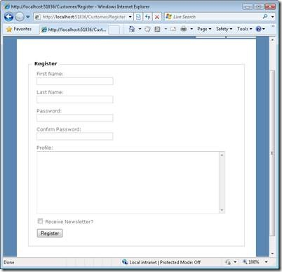

Validation Rules

Model Validations in MVC with Data Annotations

Adding Validation Rules to the Model
Add a using statement at the top of the file that references theSystem.ComponentModel.DataAnnotations namespace:

Notice the namespace does not contain System.Web. DataAnnotations provides a built-in set of validation attributes that you can apply declaratively to any class or property.
Model with Validation Implementation

Public class Register
{
[Required(ErrorMessage="FirstName Required:")]
[RegularExpression(@"^[a-zA-Z'.\s]{1,40}$",ErrorMessage="Special Characters not allowed")]
[StringLength(50, ErrorMessage = "Less than 50 characters")]
Public string FirstName { get; set; }

[Required(ErrorMessage="LastName Required:")]
[RegularExpression(@"^[a-zA-Z'.\s]{1,40}$", ErrorMessage = "Special Characters not allowed")]
[StringLength(50, ErrorMessage = "Less than 50 characters")]
Public string LastName { get; set; }

[Required(ErrorMessage="EmailId Required:")]
[RegularExpression(@"^\w+([-+.']\w+)*@\w+([-.]\w+)*\.\w+([-.]\w+)*$", ErrorMessage = "Email Format is wrong")]
[StringLength(50, ErrorMessage = "Less than 50 characters")]
Public string EmailId { get; set; }

[Required(ErrorMessage="Password Required:")]
[DataType(DataType.Password)]
[StringLength(30, ErrorMessage = "Less than 30 characters")]
Public string Password { get; set; }

[Required(ErrorMessage="Confirm Password Required:")]
[DataType(DataType.Password)]
[Compare("Password", ErrorMessage = "Confirm Password is not matching.")]
[StringLength(30, ErrorMessage = "Less than 30 characters")]
Public string ConfirmPassword { get; set; }

[Required(ErrorMessage="Street Address Required")]
[StringLength(100, ErrorMessage = "Less than 100 characters")]
Public string StreetAdd1 { get; set; }

[StringLength(100, ErrorMessage = "Less than 100 characters")]
Public string StreetAdd2 { get; set; }

[Required(ErrorMessage="City Required")]
[RegularExpression(@"^[a-zA-Z'.\s]{1,40}$", ErrorMessage = "Special Characters not allowed")]
[StringLength(50, ErrorMessage = "Less than 50 characters")]
Public string City { get; set; }

[Required(ErrorMessage="State Required")]
[RegularExpression(@"^[a-zA-Z'.\s]{1,40}$", ErrorMessage = "Special Characters not allowed")]
[StringLength(50, ErrorMessage = "Less than 50 characters")]
Public string State { get; set; }

[Required(ErrorMessage="ZipCode Required")]
[StringLength(20, ErrorMessage = "Less than 20 characters")]
Public string Zip { get; set; }

}

MVC CLIENT SIDE VALIDATIONS

When you are developing an MVC application in Visual Studio 2012 then the client-side becomes enabled by default, but you can easily enable or disable the writing of the following app setting code snippet in the web.config file.
<configuration>
<appSettings>
<add key="ClientValidationEnabled" value="true"/>
<add key="UnobtrusiveJavaScriptEnabled" value="true"/>
</appSettings>
</configuration>
The jQuery validation plug-in takes advantage of the Data Annotation attributes defined in the model, which means that you need to do very little to start using it.

MVC SERVER SIDE VALIDATIONS
ASP.NET MVC server-side validation using the Data Annotation API. The ASP.NET MVC Framework validates any data passed to the controller action that is executing. It populates a ModelState object with any validation failures that it finds and passes that object to the controller. Then the controller actions can query the ModelState to discover whether the request is valid and react accordingly.
One is to manually add an error to the ModelState object and another uses the Data Annotation API to validate the model data.

Approach 1: Manually Add Error to ModelState Object
I create a User class under the Models folder. The User class has two properties "Name" and "Email". The "Name" field has required field validations while the "Email" field has Email validation. So let's see the procedure to implement the validation. Create the User Model as in the following:
Public class User
{
Public string Name { get; set; }
Public string Email { get; set; }
}
After that, I create a controller action in User Controller (UserController.cs under Controllers folder). That action method has logic for the required validation for Name and Email validation on the Email field. I add an error message on ModelState with a key and that message will be shown on the view whenever the data is not to be validated in the model.
using System.Text.RegularExpressions;

Public class UserController : Controller
{
public ActionResult Index()
{
return View();
}
[HttpPost]
public ActionResult Index(ServerValidation.Models.User model)
{
if (string.IsNullOrEmpty(model.Name))
{
ModelState.AddModelError("Name", "Name is required");
}
if (!string.IsNullOrEmpty(model.Email))
{
string emailRegex = @"^([a-zA-Z0-9_\-\.]+)@((\[[0-9]{1,3}" +
@"\.[0-9]{1,3}\.[0-9]{1,3}\.)|(([a-zA-Z0-9\-]+\" +
@".)+))([a-zA-Z]{2,4}|[0-9]{1,3})(\]?)$";
Regex re = new Regex(emailRegex);
if (!re.IsMatch(model.Email))
{
ModelState.AddModelError("Email", "Email is not valid");
}
}
else
{
ModelState.AddModelError("Email", "Email is required");
}
if (ModelState.IsValid)
{
ViewBag.Name = model.Name;
ViewBag.Email = model.Email;
}
return View(model);
}
}
Thereafter, I create a view (Index.cshtml) for the user input under the User folder.
@model ServerValidation.Models.User
@{
ViewBag.Title = "Index";
}
@using (Html.BeginForm()) {
if (@ViewData.ModelState.IsValid)
{
if(@ViewBag.Name != null)
{
<b>
Name : @ViewBag.Name<br/>
Email : @ViewBag.Email
</b>
}
}
<fieldset>
<legend>User</legend>
<divclass="editor-label">
@Html.LabelFor(model => model.Name)
</div>
<divclass="editor-field">
@Html.EditorFor(model => model.Name)
@if(!ViewData.ModelState.IsValid)
{
<spanclass="field-validation-error">
@ViewData.ModelState["Name"].Errors[0].ErrorMessage</span>
}
</div>
<divclass="editor-label">
@Html.LabelFor(model => model.Email)
</div>
<divclass="editor-field">
@Html.EditorFor(model => model.Email)
@if (!ViewData.ModelState.IsValid)
{
<spanclass="field-validation-error">
@ViewData.ModelState["Email"].Errors[0].ErrorMessage</span>
}
</div>
<p>
<inputtype="submit"value="Create"/>
</p>
</fieldset>
}
Run the Application and Test in Various Ways
We are going to test various scenarios for testing the validation. Let’s look at each one by one.
- When all fields are empty:
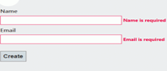
Figure 1.1: Validation Message when both fields are empty

Approach 2: Specifying Business Rules with Data Annotation
While the first approach works quite well, it does tend to break the application's separation of concerns. Namely, the controller should not contain business logic such as, the business logic belongs in the model.
Microsoft provides an effective and easy-to-use data validation API called Data Annotation in the core .NET Framework. It provides a set of attributes that we can apply to the data object class properties. These attributes offer a very declarative way to apply validation rules directly to a model.
First, create a model named Student (Student.cs) under the Models folder and applies Data Annotation attributes on the properties of the Student class.
Public class Student
{
[Required(ErrorMessage = "Name is Required")]
Public string Name { get; set; }

[Required(ErrorMessage = "Email is Required")]
[RegularExpression(@"^([a-zA-Z0-9_\-\.]+)@((\[[0-9]{1,3}" +
@"\.[0-9]{1,3}\.[0-9]{1,3}\.)|(([a-zA-Z0-9\-]+\" + @".)+))([a-zA-Z]{2,4}|[0-9]{1,3})(\]?)$",
ErrorMessage="Email is not valid")]
Public string Email { get; set; }
}

Now, create an action method in the controller (StudentController class under the Controllers folder) that returns a view with a model after the post request.
Public class StudentController : Controller
{
public ActionResult Index()
{
return View();
}
[AcceptVerbs(HttpVerbs.Post)]
public ActionResult Index(Student model)
{
if (ModelState.IsValid)
{
ViewBag.Name = model.Name;
ViewBag.Email = model.Email;
}
return View(model);
}
}
After that, I created a view (Index.cshtml) to get student details and show an error message if the model data is not valid.
@model ServerValidation.Models.Student
@{
ViewBag.Title = "Index";
}
@if (ModelState.IsValid)
{
if(@ViewBag.Name != null)
{
<b>
Name : @ViewBag.Name<br/>
Email : @ViewBag.Email
</b>
}
}
@using (Html.BeginForm()) {
@Html.ValidationSummary(true)
<fieldset>
<legend>Student</legend>
<div class="editor-label">
@Html.LabelFor(model => model.Name)
</div>
<div class="editor-field">
@Html.EditorFor(model => model.Name)
@Html.ValidationMessageFor(model => model.Name)
</div>
<div class="editor-label">
@Html.LabelFor(model => model.Email)
</div>
<div class="editor-field">
@Html.EditorFor(model => model.Email)
@Html.ValidationMessageFor(model => model.Email)
</div>
<p>
<input type="submit" value="Create"/>
</p>
</fieldset>
}

Data Annotations using MetaData class

In this approach the validation will be applied in a MetaData class and will be linked with the Model Class

Using a MetaData class
Sometimes you are not able to modify a model class, especially if it is automatically generated. In that case you can create a MetaData class for the model class, where you will place validation rules and then link he an example is shown in the following listing:
Creating the metadata class

Public class UserMetadata
{
[StringLength(50), Required]
Public object Name { get; set; }
[StringLength(5)]
Public object Email { get; set; }
[Range(0, 10)]
Public object Rating { get; set; }
}
}

Linking it with Model class

[MetadataType(typeof(UserMetadata))]
Public partial class User
{
Public string Name { get; set; }
Public string Email { get; set; }
public int Rating { get; set; }
}

In this case, in the model class is defined that UserMetaData will be the meta data class of the User class where validation rules will be placed.
In the metadata class you can put properties named the same way as properties of the model and put annotations there.
This is a useful way to implement validation even if you can modify your original model classes but you do not want to mix validation rules and properties. The only prerequisite is that the model class is defined as partial so we can put the second part of the class in a separate file.

Custom validation
The third option is to put custom validation rules directly in the controller code. An example of explicit setting of error messages in the controller is shown in the following listing:
ModelState.AddModelError("Country", "This is useless message attached to the 'Country' input");
The method AddModelError takes the ID of the input element where the error label should be shown and the text of the error message. This code is placed in the action method of the controller and it puts a new error that will be associated to the Country input.

Custom HTML Helpers

Custom HTML helpers than that can also be done very easily.

Ways of creating custom helpers.
- Creating a static method [ static Class, static methods
- Writing an extension method
- Using the @helper(razor only) [ Inside the cshtml file]
Let us try to create a simple HTML helper method which will create a marked HTML label.

Creating a static method

In this approach we can simply create a static class with static method which will return the HTML string to be used at the time of rendering.
namespace HTMLHelpersDemo.Helpers
{
public static class MyHTMLHelpers
{
public static IHtmlString LabelWithMark(string content)
{
string htmlString = String.Format("<label><mark>{0}</mark></label>", content);
return new HtmlString(htmlString);
}
}
}
@MyHTMLHelpers.LabelWithMark(“suresh”)
@Html.TextBox(“Name”);

Writing an extension method
In this approach we will write a simple extension method for the built in html helper class. This will enable us to use the same Html object to use our custom helper method.

public static class MyExtensionMethods

{

public static IHtmlString LabelWithMark(this HtmlHelper helper, string content)

{

string htmlString = String.Format("<label><mark>{0}</mark></label>", content);

return new HtmlString(htmlString);

}

}
public static class MyExtensionMethods
{
public static IHtmlString Header1(this HtmlHelper helper,string text)
{
return new HtmlString("<h1 style='background-color:blue'>" + text + "</h1>");

}

Using the @helper(razor only)
This method is pretty specific to razor view engine. Let us see how this can be done. We need to write this method in the view itself.
@helper LabelWithMarkRazor(string content)
{
<label><mark>@content</mark></label>
}
@helper Header(string content)
{
<h1>@content</h1>
<h2>@content</h2>
<h3>@content</h3>
}

Note: By default these helpers will be available in the view they are defined in. If we want to use the razor created helpers in multiple views then we have to put all of them in one view and put that view file in App_Code directory. This way they will be usable from all the views.
Now we have the same html helper method written in 3 different ways, Let us create a simple view and try to use these helper methods.
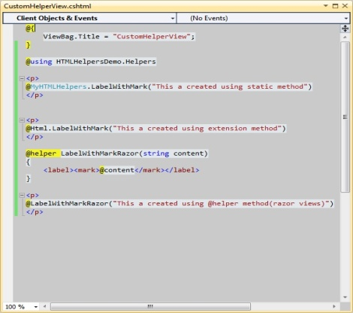
Lets run the application and see the result:
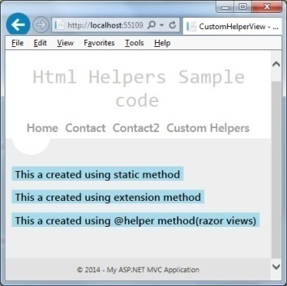

.NET MVC - Security
We will discuss how to implement security features in the application. We will also look at the new membership features included with ASP.NET and available for use from ASP.NET MVC. In the latest release of ASP.NET, we can manage user identities with the following −
- Cloud
- SQL database
- Local Windows active directory
In this chapter, we will also take a look at the new identity components that is a part of ASP.NET and see how to customize membership for our users and roles.

Authentication
Authentication of user means verifying the identity of the user. This is really important. You might need to present your application only to the authenticated users for obvious reasons.
Let’s create a new ASP.Net MVC application.
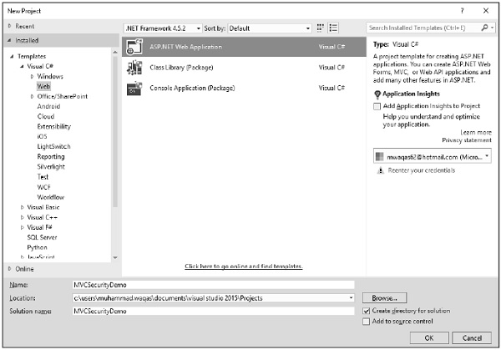
Click OK to continue.
When you start a new ASP.NET application, one of the steps in the process is configuring the authentication services for application needs.
Select MVC template and you will see that the Change Authentication button is now enabled.
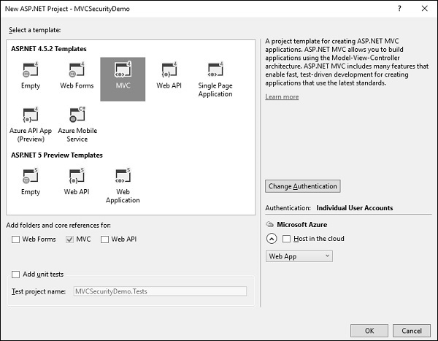
This is done with the Change Authentication button that appears in the New Project dialog. The default authentication is, Individual User Accounts.

Authentication Options
When you click the Change button, you will see a dialog with four options, which are as follows.

No Authentication
The first option is No Authentication and this option is used when you want to build a website that doesn't care who the visitors are.
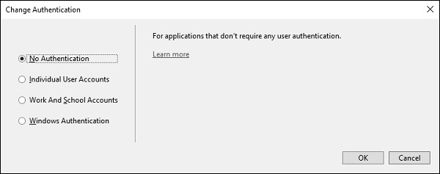
It is open to anyone and every person connects as every single page. You can always change that later, but the No Authentication option means there will not be any features to identify users coming to the website.

Individual User Accounts
The second option is Individual User Accounts and this is the traditional forms-based authentication where users can visit a website. They can register, create a login, and by default their username is stored in a SQL Server database using some new ASP.NET identity features, which we'll look at.
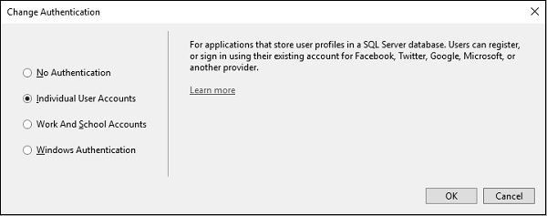
The password is also stored in the database, but it is hashed first. Since the password is hashed, you don't have to worry about plain-text passwords sitting in a database.
This option is typically used for internet sites where you want to establish the identity of a user. In addition to letting a user create a local login with a password for your site, you can also enable logins from third parties like Microsoft, Google, Facebook, and Twitter.
This allows a user to log into your site using their Live account or their Twitter account and they can select a local username, but you don't need to store any passwords.
This is the option that we'll spend some time with in this module; the individual user accounts option.

Work and School Accounts
The third option is to use organizational accounts and this is typically used for business applications where you will be using active directory federation services.
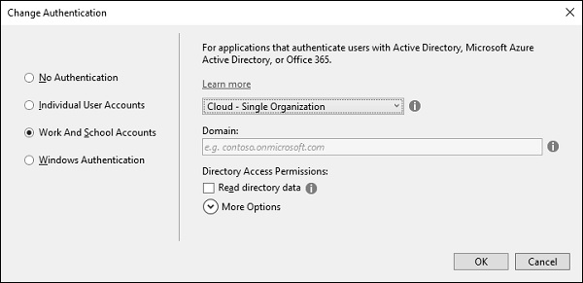
You will either set up Office 365 or use Azure Active Directory Services, and you have a single sign-on for internal apps and Cloud apps.
You will also need to provide an app ID so your app will need to be registered with the Windows Azure management portal if this is Azure based, and the app ID will uniquely identify this application amongst all the applications that might be registered.

Windows Authentication
The fourth option is Windows authentication, which works well for intranet applications.
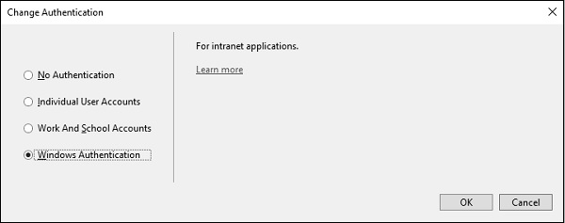
A user logs into Windows desktop and can launch a browser to the application that sits inside the same firewall. ASP.NET can automatically pick up the user's identity, the one that was established by active directory. This option does not allow any anonymous access to the site, but again that is a configuration setting that can be changed.
Let's take a look into the forms-based authentication, the one that goes by the name, Individual User Accounts. This application will store usernames and passwords, old passwords in a local SQL Server database, and when this project is created, Visual Studio will also add NuGet packages.
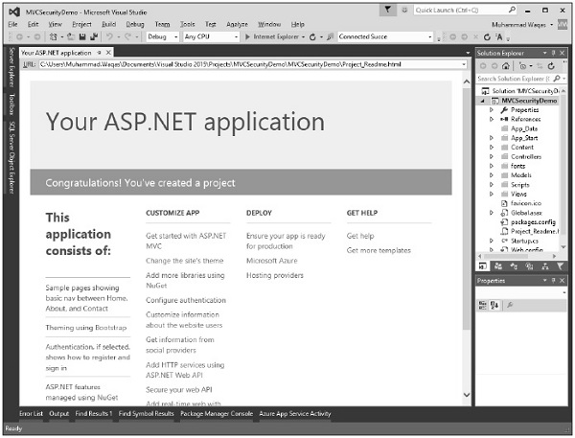
Now run this application and when you first come to this application you will be an anonymous user.
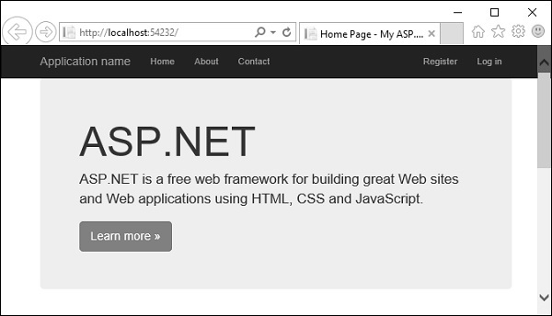
You won't have an account that you can log into yet so you will need to register on this site.
Click on the Register link and you will see the following view.
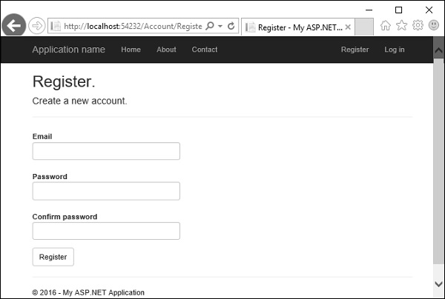
Enter your email id and password.
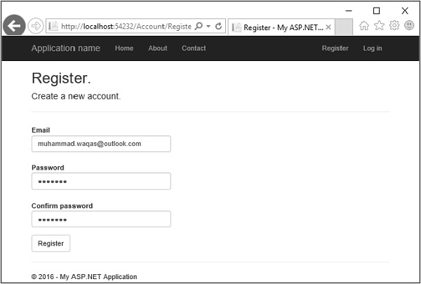
Click Register. Now, the application will recognize you.
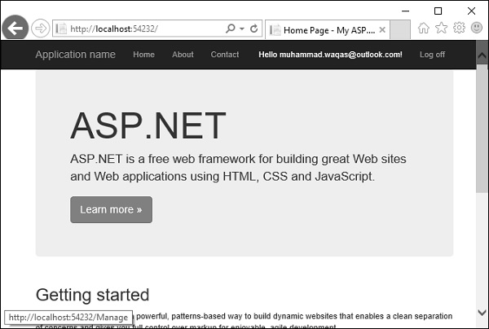
It will be able to display your name. In the following screenshot, you can see Hello, muhammad.waqas@outlook.com! is displayed. You can click on that and it's a link to a page where you can change the password.
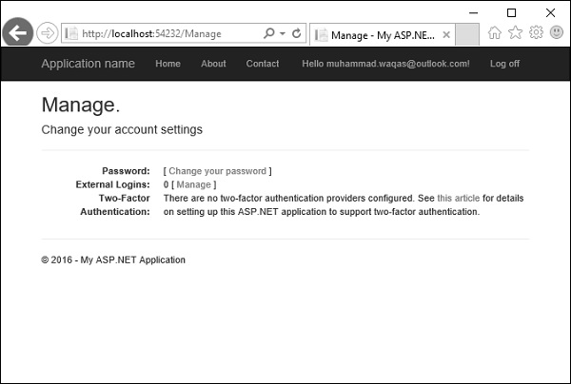
You can also log off, shut down, reboot, come back a week later, and you should be able to log in with the credentials that you used earlier. Now click on the log off button and it will display the following page.
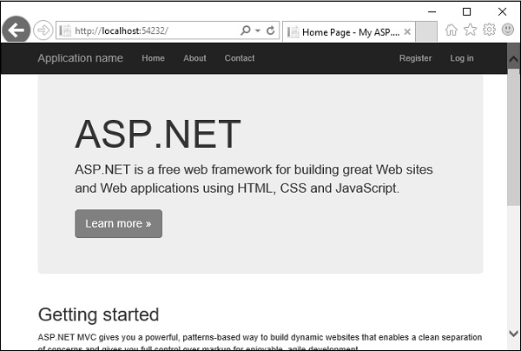
Click again on the Log in link and you will go to the following page.
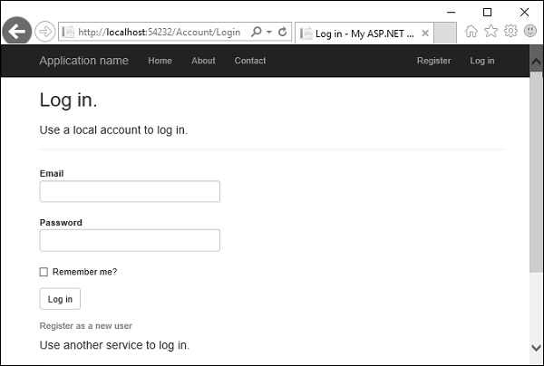
You can login again with the same credentials.
A lot of work goes on behind the scene to get to this point. However, what we want to do is examine each of the features and see how this UI is built. What is managing the logoff and the login process? Where is this information sorted in the database?
Let's just start with a couple of simple basics. First we will see how is this username displayed. Open the _Layout.cshtml from the View/Shared folder in the Solution explorer.
<!DOCTYPE html>
<html>
<head>
<meta charset = "utf-8" />
<meta name = "viewport" content = "width = device-width, initial-scale = 1.0">
<title>@ViewBag.Title - My ASP.NET Application</title>
@Styles.Render("~/Content/css")
@Scripts.Render("~/bundles/modernizr")
</head>

<body>
<div class = "navbar navbar-inverse navbar-fixed-top">
<div class = "container">

<div class = "navbar-header">
<button type = "button" class = "navbar-toggle" datatoggle = "collapse"
data-target = ".navbar-collapse">
<span class = "icon-bar"></span>
<span class = "icon-bar"></span>
<span class = "icon-bar"></span>
</button>

@Html.ActionLink("Application name", "Index", "Home", new
{ area = "" }, new { @class = "navbar-brand" })
</div>

<div class = "navbar-collapse collapse">
<ul class = "nav navbar-nav">
<li>@Html.ActionLink("Home", "Index", "Home")</li>
<li>@Html.ActionLink("About", "About", "Home")</li>
<li>@Html.ActionLink("Contact", "Contact", "Home")</li>
</ul>

@Html.Partial("_LoginPartial")
</div>

</div>

</div>
<div class = "container body-content">
@RenderBody()
<hr />
<footer>
<p>© @DateTime.Now.Year - My ASP.NET Application</p>
</footer>
</div>

@Scripts.Render("~/bundles/jquery")
@Scripts.Render("~/bundles/bootstrap")
@RenderSection("scripts", required: false)

</body>
</html>
There is a common navigation bar, the application name, the menu, and there is a partial view that's being rendered called _loginpartial. That's actually the view that displays the username or the register and login name. So _loginpartial.cshtml is also in the shared folder.
@using Microsoft.AspNet.Identity
@if (Request.IsAuthenticated) {
using (Html.BeginForm("LogOff", "Account", FormMethod.Post,
new { id = "logoutForm", @class = "navbar-right" })){
@Html.AntiForgeryToken()
<ul class = "nav navbar-nav navbar-right">
<li>
@Html.ActionLink("Hello " + User.Identity.GetUserName() + "!",
"Index", "Manage", routeValues: null, htmlAttributes: new { title = "Manage" })
</li>

<li>
<a href = "javascript:document.getElementById('logoutForm').submit()">Logoff</a>
</li>

</ul>
}
}else{
<ul class = "nav navbar-nav navbar-right">
<li>@Html.ActionLink("Register", "Register", "Account", routeValues:
null, htmlAttributes: new { id = "registerLink" })</li>

<li>@Html.ActionLink("Log in", "Login", "Account", routeValues: null,
htmlAttributes: new { id = "loginLink" })</li>
</ul>
}
As you can see above, there are if/else statements. If we do not know who the user is, because the request is not authenticated, this view will display register and login links. The user can click on the link to log in or register. All this is done by the account controller.
For now, we want to see how to get the username, and that's inside Request.IsAuthenticated. You can see a call to User.Identity.GetUserName. That will retrieve the username, which in this case is ‘muhammad.waqas@outlook.com’

Authorization
Let's suppose that we have some sort of information which we want to protect from unauthenticated users. So let’s create a new controller to display that information, but only when a user is logged in.
Right-click on the controller folder and select Add → Controller.
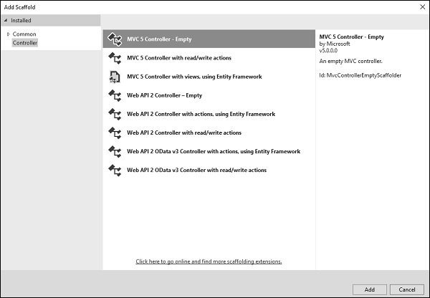
Select an MVC 5 controller - Empty controller and click ‘Add’.
Enter the name SecretController and click ‘Add’ button.
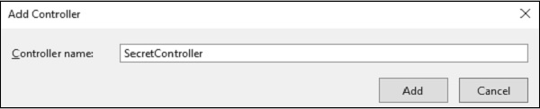
It will have two actions inside as shown in the following code.
using System.Web.Mvc;

namespace MVCSecurityDemo.Controllers{
public class SecretController : Controller{
// GET: Secret
public ContentResult Secret(){
return Content("Secret informations here");
}

public ContentResult PublicInfo(){
return Content("Public informations here");
}
}
}
When you run this application, you can access this information without any authentication as shown in the following screenshot.
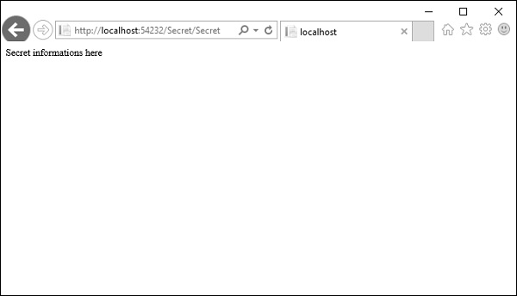
So only authenticated users should be able to get to Secret action method and the PublicInfo can be used by anyone without any authentication.
To protect this particular action and keep unauthenticated users from arriving here, you can use the Authorize attribute. The Authorize attribute without any other parameters will make sure that the identity of the user is known and they're not an anonymous user.
// GET: Secret
[Authorize]
public ContentResult Secret(){
return Content("Secret informations here");
}
Now run this application again and specify the same URL http://localhost:54232/Secret/Secret. The MVC application will detect that you do not have access to that particular area of the application and it will redirect you automatically to the login page, where it will give you a chance to log in and try to get back to that area of the application where you were denied.
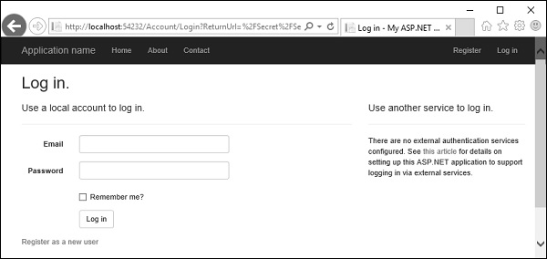
You can see that it is specified in the return URL, which essentially tells this page that if the user logs in successfully, redirect them back to /secret/secret.
Enter your credentials and click ‘Log in’ button. You will see that it goes directly to that page.

If you come back to the home page and log off, you cannot get to the secret page. You will be asked again to log in, but if go to /Secret/PublicInfo, you can see that page, even when you are not authenticated.
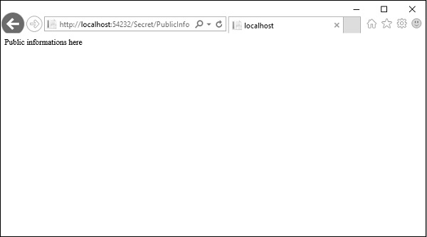
So, when you don't want to be placing authorization on every action when you're inside a controller where pretty much everything requires authorization. In that case you can always apply this filter to the controller itself and now every action inside of this controller will require the user to be authenticated.
using System.Web.Mvc;

namespace MVCSecurityDemo.Controllers{
[Authorize]
public class SecretController : Controller{
// GET: Secret
public ContentResult Secret(){
return Content("Secret informations here");
}

public ContentResult PublicInfo(){
return Content("Public informations here");
}
}
}
But if you really want any action to be open, you can come override this authorization rule with another attribute, which is, AllowAnonymous.
using System.Web.Mvc;

namespace MVCSecurityDemo.Controllers{
[Authorize]
public class SecretController : Controller{
// GET: Secret
public ContentResult Secret(){
return Content("Secret informations here");
}

[AllowAnonymous]
public ContentResult PublicInfo(){
return Content("Public informations here");
}
}
}
Run this application and you can access the /Secret/PublicInfo with logging in but other action will require authentication.

It will allow anonymous users into this one action only.
With the Authorize attribute, you can also specify some parameters, like allow some specific users into this action.
using System.Web.Mvc;

namespace MVCSecurityDemo.Controllers{
[Authorize(Users = "ali.khan@outlook.com")]
public class SecretController : Controller{
// GET: Secret
public ContentResult Secret(){
return Content("Secret informations here");
}

[AllowAnonymous]
public ContentResult PublicInfo(){
return Content("Public informations here");
}
}
}
When you run this application and go to /secret/secret, it will ask you to log in because it is not the proper user for this controller.
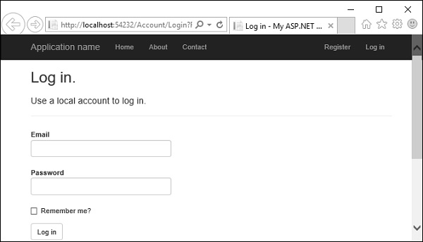

Layouts
Layouts are templates which can be inherited by other pages / views. It is similar to master pages.
Using layouts we can define the header and footer which needs to be common in all the views of MVC.
We can create different layouts and link it to different view.
Layouts allows you to define a common site template, and then inherit its look and feel across all the views/pages on your web application.

Create an MVC Application
I will create an MVC application using Visual Studio 2012.
Step 1: Go to "File" -> "New" -> "Project...".
Step 2: Choose "ASP.NET MVC 4 Web Application" from the list, then give the application name "LayoutMvcApplication" and set the path in the location input where you want to create the application.
Step 3: Now choose the Project Template "Empty" and select "Razor" as the view engine from the dropdown list.

Create Layout for Application
A layout is used to provide a consistent look and feel of all pages of a web application so we create a layout for the web application. Let's see the procedure for that.
Step 1: Create a "Content" folder in the root directory of the web application.
Step 2: Create a Style Sheet "Site.css" under the content folder. That CSS file contains all CSS classes necessary for a consistent web application page design.
Step 3: Create a "Shared" folder under the "View" folder.
Step 4: Create a "_Layout.cshtml" file under the "Shared" folder. The file "_Layout.cshtml" represents the layout of each page in the application. Right-click on the Shared folder in Solution Explorer, then go to "Add" item and click on "View".
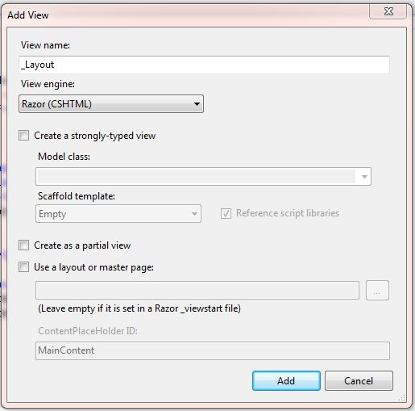
Figure 1.1 Create a layout for application
Now the View has been created. Write the following code in the "_Layout.cshtml" file.
<!DOCTYPE html>
<html lang="en">
<head>
<meta charset="utf-8" />
<title>@ViewBag.Title - Code Express</title>
<link href="~/favicon.ico"
rel="shortcut icon" type="image/x-icon" />
<link rel="stylesheet"
href="@Url.Content("~/Content/Site.css")" />
</head>
<body>
<header>
<div class="content-wrapper">
<div class="float-left">
<p class="site-title">
@Html.ActionLink("Code Express",
"Index", "Home")
</p>
</div>
<div class="float-right">
<nav>
<ul id="menu">
<li>@Html.ActionLink("Home", "Index", "Home")</li>
<li>@Html.ActionLink("About", "About", "Home")</li>
</ul>
</nav>
</div>
</div>
</header>
<div id="body">
@RenderSection("featured", required: false)
<section class="content-wrapper main-content clear-fix">
@RenderBody()
</section>
</div>
<footer>
<div class="content-wrapper">
<div class="float-left">
<p>&copy; @DateTime.Now.Year&acirc;&euro;&ldquo; Code Express</p>
</div>
</div>
</footer>
</body>
</html>

In this layout, we are using an HTML helper method and some other system defined methods so let's see these methods one by one.
- RenderBody(): In layout pages, renders the portion of a content page that is not within a named section. It returns the HTML content to render. RenderBody is required, since it's what renders each view.

- RenderSection(): RenderSection() is a method of the WebPageBase class. The first parameter to the "RenderSection()" helper method specifies the name of the section we want to render at that location in the layout template. The second parameter is optional, and allows us to define whether the section we are rendering is required or not. If a section is "required", then Razor will throw an error at runtime if that section is not implemented within a view template that is based on the layout file (that can make it easier to track down content errors). It returns the HTML content to render.

The _ViewStart File
The "_ViewStart" file in the Views folder contains the following content:
@{
Layout = "~/Views/Shared/_Layout.cshtml";
}

Now add a view and select layout page designed. The view will inherit the design from the layout.

Partial View
Partial view is special view which renders a portion of view content.
It is just like a user control web form application.
Partial can be reusable in multiple views.
It helps us to reduce code duplication. In other word a partial view enables us to render a view within the parent view.
The partial view is instantiated with its own copy of a ViewDataDictionary object which is available with the parent view so that partial view can access the data of the parent view. If we made the change in this data (ViewDataDictionary object), the parent view's data is not affected. Generally the Partial rendering method of the view is used when related data that we want to render in a partial view is part of our model.
Creating Partial View
To create a partial view, right-click on view -> shared folder and select Add -> View option. In this way we can add a partial view.
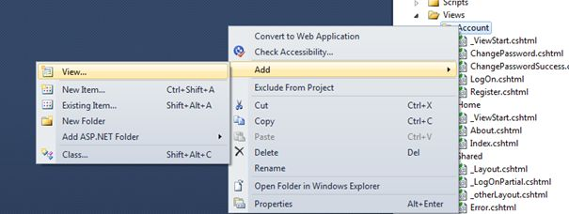
It is not mandatory to create a partial view in a shared folder but a partial view is mostly used as a reusable component, it is a good practice to put it in the "shared" folder.
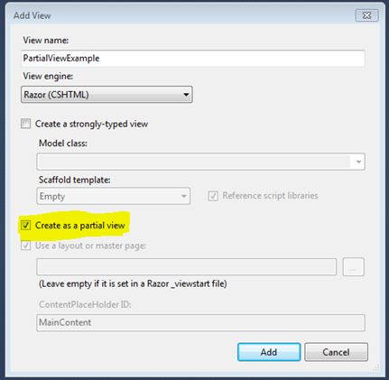
Contoller – ActionName ->PartialView
Folder -> Add PartialView
HTML helper has two methods for rendering the partial view: Partial and RenderPartial.
- <div>
- @Html.Partial("PartialViewExample",@model) //NormalView
- </div>
- <div>
- @{
- Html.RenderPartial("PartialViewExample",@model); //NormalView
- }
- </div>
@Html.RenderPartial
The result of the RenderPartial method is written directly into the HTTP response, it means that this method used the same TextWriter object as used by the current view. This method returns nothing.
@Html.Partial
This method renders the view as an HTML-encoded string. We can store the method result in a string variable.
The Html.RenderPartial method writes output directly to the HTTP response stream so it is slightly faster than the Html.Partial method.
Returning a Partial view from the Controller's Action method:
- public ActionResult PartialViewExample()
- {
- return PartialView();
- }
Render Partial View Using jQuery
Sometimes we need to load a partial view within a model popup at runtime, in this case we can render the partial view using JQuery element's load method.
- <script type="text/jscript">
- $('#partialView').load('/shared/PartialViewExample’);
- </script>

View Vs Partial View

View | Partial View
View contains the layout page | Partial view does not contain the layout page
_viewstart page is rendered before any view is rendered | Partial view does not check for a _viewstart.cshtml. We cannot place any common code for a partial view within the _viewStart.cshtml page.
View may have markup tags like html, body, head, title, meta etc. | The Partial view is specially designed to render within the view and as a result it does not contain any mark up.
Partial view is more lightweight than the view. We can also pass a regular view to the RenderPartial method.
If there is no layout page specified in the view, it can be considered as a partial view. In razor, there is no distinction between views and partial views as in the ASPX view engine (aspx and ascx).

Areas :
Areas are functionally independent modules of your ASP.NET MVC application that mimic the folder structure and conventions of MVC.
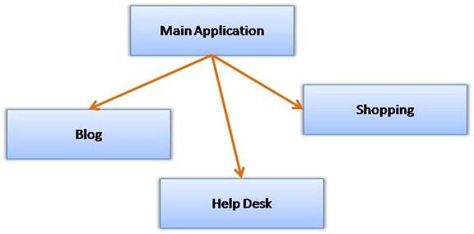
As you can see the main application has three functionally independent modules viz. Blog, Help Desk and Shopping. Without any areas in place, you would have put all the controllers and views in the respective folder of the main application folder.
For example, you cannot have HomeController for Blog and HomeController for HelpDesk. You either need to put all action methods of both the modules in a single controller or create two controllers with altogether different names (say BlogHomeController and HelpDeskHomeController).
With areas in place, each module replicates the MVC folder structure.
For example, each module will have its own Models, Views and Controllers folder. You can then have HomeController class in Blog module as well as HelpDesk module. So, in the above example, essentially you will have four MVC structures - one for the main application and one each for the three modules (Blog, HelpDesk and Shopping).

Adding a New Area
Before you work with areas, create a new ASP.NET MVC application with ASPX view engine.
To add a new area right click on the application in the Solution Explorer and select the Add > Area shortcut menu option. Doing so will open "Add Area" dialog as shown below:
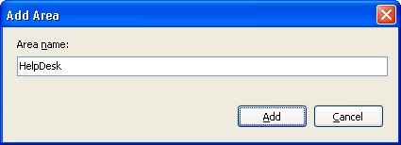
You need to enter the Area Name and click the Add button to create the folder structure for that area. The following figure shows the complete folder structure with three Areas - Blog, HelpDesk and Shopping - added.
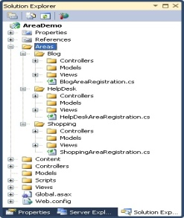
As you can see, the main application has Areas subfolders. Inside the Areas subfolders there is a folder for each area you wish to create (Blog, HelpDesk and Shpping in the above example). Each Areaa subfolder has its own set of MVC folders (Models, Views and Controllers). You can treat each area just like the main application and add models, views and controllers in the respective folders.

Registering Areas with MVC Framework
Simply creating area folder structure is not sufficient, you also need to inform ASP.NET MVC framework about the areas you've added. Luckily, this task is automatically done when you add a new area.
Notice the area registration class file that was created under each area folder (BlogAreaRegistration.cs, HelpDeskAreaRegistration.cs, etc.).
The area registration file contains a class that inherits from AreaRegistration base class.
The HelpDeskAreaRegistration class is shown below :
- public class HelpDeskAreaRegistration : AreaRegistration
- {
- public override string AreaName
- {
- get
- {
- return "HelpDesk";
- }
- }
- public override void RegisterArea(AreaRegistrationContext context)
- {
- context.MapRoute(
- "HelpDesk_default",
- "HelpDesk/{controller}/{action}/{id}",
- new { action = "Index", id = UrlParameter.Optional } );
- }
- }
As you can see the HelpDeskAreaRegistration class overrides AreaName property and the RegisterArea method. The RegisterArea method registers the route information for the newly added area with MVC framework.
You will have one area registration class file for each area. When are the area registration classes used? If you open Global.asax file, you will have the following code in the Application_Start event handler :
- protected void Application_Start()
- {
- AreaRegistration.RegisterAllAreas();
- RegisterGlobalFilters(GlobalFilters.Filters);
- RegisterRoutes(RouteTable.Routes);
- }
As you can see, there is a call to RegisterAllAreas() static method of AreaRegistration class. Calling RegisterAllAreas() method in turn invokes the RegisterArea() method of all the area registration classes found in the application.
Before going ahead, add HomeController to all the areas and the main application, i.e. four controller classes with name HomeController. All the HomeController classes will look like this :
- public class HomeController : Controller
- {
- public ActionResult Index()
- {
- return View();
- }
- }Then right click on each Index() action method and add Index view, i.e. total four Index views in their respective folders.
Run the application and try navigating to different areas. The following figure shows a sample run for HelpDesk area. Notice the URL of the area.
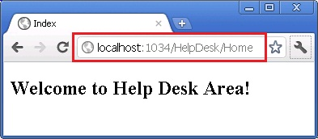
Calling an Action within an Area
http://localhost/Application/Area/ControllerName/Action

Linking Between Two Areas
ASP.NET MVC Views often need to link to some action method residing in controller classes. Unless otherwise specified, action methods and controllers are assumed to be from the current area. In case you wish to link to an action method belonging to some other area, here is how you would do just that:
- <h3>You are inside main area. To navigate to some other area please click on the following links</h3>
- <%= Html.ActionLink("Main Area", "Index", "Home", new { area = "" }, null)%>
- <br /><br />
- <%= Html.ActionLink("Blog Area", "Index", "Home", new { area = "Blog",id=1 }, null)
Html.ActionLink("Blog Area", "Index", "Home", new { area = "Blog",id=1 }, null)%>
- <br /><br />
- <%=
- Html.ActionLink("Help Desk Area", "Index", "Home", new { area = "HelpDesk" }, null)
- Html.ActionLink("LinkTest", "ActionName", "ControllerName", new { area = "AreaName" }, null)

- %>
- <br /><br />
- <%= Html.ActionLink("Shopping Area", "Index", "Home", new { area = "Shopping" }, null)%>
The above fragment is from the Index view of the main area. It renders four hyperlinks using ActionLink(). Notice the fourth parameter that specifies area name. This parameter governs the area whose action method is being linked to.

Redirecting to an Action Belonging to Another Area
You can also redirect to some action method of a specific area using RedirectToAction() method. Consider the following action method:
Public ActionResult Index()
{
Return RedirectToAction("Index", "Home", new { Area = "HelpDesk" });
Return RedirectToAction("ActionName", "ControllerName", new { Area = "AreaName" });

}
As you can see, the Index() action method of the main area redirects the control to Index() action method of the HelpDesk area.
ASP.NET MVC allows you to organize your application into areas. Each area replicates the MVC structure and can be treated as independent as far as models, views and controllers are concerned. An area is registered with MVC framework using an area registration class and RegisterAllAreas() call in the Global.asax file.

Routing in MVC
Basically, Routing is a pattern matching system that monitors the incoming request and figure out what to do with that request. At runtime, Routing engine use the Route table for matching the incoming request's URL pattern against the URL patterns defined in the Route table.
  - Routing plays important role in MVC framework. Routing maps URL to physical file or class (controller class in MVC).
  - Route contains URL pattern and handler information. URL pattern starts after domain name.
  - Routes can be configured in RouteConfig class. Multiple custom routes can also be configured.
  - Route constraints applies restrictions on the value of parameters.
  - Route must be registered in Application_Start event in Global.ascx.cs file.
You can register one or more URL patterns to the Route table at Application_Start event.

How to define route...
- Public static void RegisterRoutes(RouteCollection routes)
- {
- routes.MapRoute(

- "Default",// Route name
- "{controller}/{action}/{id}",// Route Pattern
- new{ controller ="Home", action ="Index", id =UrlParameter.Optional}
- // Default values for above defined parameters
- );
- }

- protectedvoidApplication_Start()
- {
- RegisterRoutes(RouteTable.Routes);
- //To:DO
- }
When the routing engine finds a match in the route table for the incoming request's URL, It forwards the request to the appropriate controller and action. If there is no match in the route table for the incoming request's URL, it returns a 404 HTTP status code.
Note : Always remember route name should be unique across the entire application.
Route name can’t be duplicate.
How it works. : In above example we have defined the Route Pattern {controller}/{action}/{id} and also provide the default values for controller, action and id parameters.
Default values means if you will not provide the values for controller or action or id defined in the pattern then these values will be serve by the routing system.
Suppose your web application is running on www.example.com then the urlpattren for you application will be www.example.com/{controller}/{action}/{id}.
Hence you need to provide the controller name followed by action name and id if it is required. If you will not provide any of the value then default values of these parameters will be provided by the routing system. Here is a list of URLs that match and don't match this route pattern.
Matching URLs
Request URL | Parameters
http://example.com/ | Controller=Home, action=Index, id=none, Since default value of controller and action are Home and Index respectively.
http://example.com/Admin | controller=Admin, action=Index, id=none, Since default value of action is Index
http://example.com/Admin/Product | controller=Admin, action=Product, id=none
http://example.com/Admin/Product/1 | controller=Admin, action=Product, id=1
http://example.com/Admin/Product/SubAdmin/1 | No Match Found
http://example.com/Admin/Product/SubAdmin/Add/1 | No Match Found

Creating Custom Routes (C#) :How to add a custom route to an ASP.NET MVC application. You learn how to modify the default route table in the Global.asax file with a custom route.
For many simple ASP.NET MVC applications, the default route table will work just fine. However, you might discover that you have specialized routing needs. In that case, you can create a custom route.
Imagine, for example, that you are building a blog application. You might want to handle incoming requests that look like this:
/Archive/12-25-2009
When a user enters this request, you want to return the blog entry that corresponds to the date 12/25/2009. In order to handle this type of request, you need to create a custom route.
The Global.asax file in Listing 1 contains a new custom route, named Blog, which handles requests that look like /Archive/entry date.
public class RouteConfig
{
public static void RegisterRoutes(RouteCollection routes)
{
routes.IgnoreRoute("{resource}.axd/{*pathInfo}");
routes.MapRoute(
name: "Test",
url: "Employee",
defaults: new { controller = "Employee", action = "Index", id = UrlParameter.Optional });

routes.MapRoute(
name: "Entry",
url: "Entry",
defaults: new { controller = "Archive", action = "Entry" });

routes.MapRoute(
name: "Default",
url: "{controller}/{action}/{id}",
defaults: new { controller = "Home", action = "Index", id = UrlParameter.Optional });
}
}
The order of the routes that you add to the route table is important. Our new custom Blog route is added before the existing Default route. If you reversed the order, then the Default route always will get called instead of the custom route.
The custom Blog route matches any request that starts with /Archive/. So, it matches all of the following URLs:
/Archive/12-25-2009
/Archive/10-6-2004

/Archive/apple
/Archive/NewAction/
The custom route maps the incoming request to a controller named Archive and invokes the Entry() action. When the Entry() method is called, the entry date is passed as a parameter named entryDate.
You can use the Blog custom route with the controller in Listing 2.
public class ArchiveController : Controller
{
public string Entry(DateTime entryDate)
{
return "You requested the entry from " + entryDate.ToString();
}
}

Notice that the Entry() method in Listing 2 accepts a parameter of type DateTime. The MVC framework is smart enough to convert the entry date from the URL into a DateTime value automatically. If the entry date parameter from the URL cannot be converted to a DateTime, an error is raised (see Figure 1). Figure 1 - Error from converting parameter

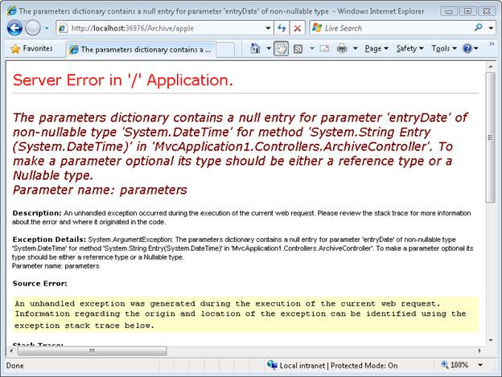
The goal of this tutorial was to demonstrate how you can create a custom route. You learned how to add a custom route to the route table in the Global.asax file that represents blog entries. We discussed how to map requests for blog entries to a controller named ArchiveController and a controller action named Entry().
Routing is a pattern matching system that monitor the incoming request and figure out what to do with that request. At runtime, Routing engine use the Route table for matching the incoming request's URL pattern against the URL patterns defined in the Route table. You can register one or more URL patterns to the Route table at Application_Start event.

How to define route...
Public static void RegisterRoutes(RouteCollection routes)
{
routes.MapRoute( "Default", // Route name
"{controller}/{action}/{id}", // Route Pattern
new { controller = "Home", action = "Index", id = UrlParameter.Optional } );
}
Protected void Application_Start()
{
RegisterRoutes(RouteTable.Routes);
//To:DO
}

Minification

Minification is technique for removing unnecessary characters (like white space, newline, tab) and comments from the JavaScript and CSS files to reduce the size which cause improved load times of a webpage. There are so many tools for minifying the js and css files. JSMin and YUI Compressor are two most popular tools for minifying the js and css files.
You can also add WebEssentials2012.vsix extension to your VS2012 for minifying the js and css files. This is a great extension for VS2012 for playing with js and css.

Unobtrusive Validations

"Unobtrusive Validation" Mean?
It means that we can implement simple client-side validation without writing a ton of validation code, and that we can improve the user experience simply by adding the appropriate attributes and including the appropriate script files.
To turn unobtrusive JavaScript mode on/off and enable/disable client validation by default for the entire application, you can use Web.config:

1  2  3  4  5  6 | <configuration>  <appSettings>  <add key="ClientValidationEnabled" value="true"/>  <add key="UnobtrusiveJavaScriptEnabled" value="true"/>  </appSettings>  </configuration>
You can also turn them on or off with code:
HtmlHelper.ClientValidationEnabled = true;
HtmlHelper.UnobtrusiveJavaScriptEnabled = true;

Action filter attributes can be applied to an individual action method or to a controller. When applied to a controller, it will be applicable to all the action methods written for that controller.

MVC Filters

Developers can use an MVC filter to perform certain actions before or after a particular operation or during a pre- or post-action behavior from the action. MVC filters are used to perform common functionalities in an ASP.NET MVC application, such as custom authentication and authorization, error handling or logging, user activity logging, data caching, and data compression.

Types of Filters
There are five types of Filters in ASP.NET MVC 5.0:
- Authentication Filters (available in ASP.NET MVC5)
- Authorization Filters
- Action Filters
- Result Filters
- Exception Filters
- Filter Type | Interface | Description
Authentication | IAuthenticationFilter | These are Runs, before any other filters or the action method.
Authorization | IAuthorizationFilter | These Runs first, before any other filters or the action method.
Action | IActionFilter | These Runs before and after the action method.
Result | IResultFilter | Runs before and after the action result are executed.
Exception | IExceptionFilter | Runs only if another filter, the action method, or the action resultthrows an exception.

Examples of ASP.NET MVC Filters

Authentication Filters
Introduced with ASP.NET MVC5, an authentication filter is a component that authenticates an HTTP request. Both Web API 2 and MVC 5 support authentication filters. The IAuthenticationFilter interface is used to create CustomAuthentication filter. Refer the following code snippet.
- namespace MVCFilters
- {
- public interface IAuthenticationFilter
- {
- void OnAuthentication(AuthenticationContext
- AuthenticationFilterContext);

- void OnAuthenticationChallenge(AuthenticationChallengeContext
- filterContext);
- }

- public class CustomAuthenticationAttribute :
- ActionFilterAttribute, IAuthenticationFilter
- {
- public void OnAuthentication(AuthenticationContext
- filterContext)
- {
- // Custom logic for user authentication
- }

- public void OnAuthenticationChallenge
- (AuthenticationChallengeContext filterContext)
- {
- // Any Additional tasks on the request

- }
- }
- }

Authorization Filters
Authorization filters are required to provide an authorization level in the application. The ASP.NET MVC Authorize filter attribute implements the IAuthorizationFilter interface. Also, the AuthorizeAttribute class provides the following methods to override in the CustomAuthorize attribute class.
The following snippet shows how the Interface and the class operate.
- namespace MVCFilters
- {
- public interface IAuthorizationFilter
- {
- void OnAuthorization(AuthorizationContext filterCOntext);
- }

- public class AuthorizeAttribute : FilterAttribute,
- IAuthorizationFilter
- {
- protected virtual bool AuthorizeCore(HttpContextBase
- httpContext);
- protected virtual void HandleUnauthorizedRequest
- (AuthorizationContext filterContext);
- public virtual void OnAuthorization(AuthorizationContext
- filterContext);
- protected virtual HttpValidationStatus OnCacheAuthorization
- (HttpContextBase httpContext);
- }

- }

Action Filters
Action filters are used to implement the logic that get executed before or after a controller action executes. The IActionFilter interface is used to create an Action Filter. That interface provides two methods: OnActionExecuting and OnActionExecuted. These methods will be executed before or after an action is executed, respectively.
- namespace MVCFilters
- {
- public interface IActionFilter
- {
- void OnActionExecuting(ActionExecutingContext filterContext);
- void OnActionExecuted(ActionExecutedContext filterContext);
- }
- }
ASP.NET MVC provides the following action filters:
- Output Cache: Caches the output of a controller action for a specified amount of time. One of the important features of output cache is that it supports an action filter that can be called all the time, even when the action is marked with a cache attribute.
  - namespace MVCFiltere
  - {
  - [LogThis]
  - [DonutOutputCache(Duration = 5, Order = 100)]
  - public ActionResult Index()

  - }
- Handle Error: A filter that works when you have enabled the custom errors in web.config. The HandleError attribute could be applied over the action method as well as controller level and global level. The HandleError attribute is generally added in the Global.asax.cs file and registered in the Application_Start event.
- Authorize: This action filter enables developers to restrict access to a particular user or role.

Result Filters
Result filters contain logic for executing before or after generating the result for an action. The IResultFilter interface is used to create a Result Filter.
Result filters are performed through the IResultFilter interface. That interface provides two methods: OnResultExecuting and OnResultExecuted. These methods will be executed before or after generating the result for an action.
- namespace MVCFiltere
- {
- public interface IResultFilter
- {
- void OnResultExecuting(ResultExecutingContext filterContext);
- void OnResultExecuted(ResultExecutedContext filterContext);
- }
- }

Exception Filters
Exception filters are used for handling errors. Exception filters can catch an exception caused by either a controller action or controller action results. Exception filters are also used for logging the exceptions. The IExceptionFilter interface is used to create an Exception Filter which provides the OnException method which will be executed when exception occurs during the action's execution or filter's execution.
- namespace MVCFiltere
- {
- public interface IExceptionFilter
- {
- void OnException(ExceptionContext filterContext);
- }
- }

